

**CAPSTONE PROJECT REPORT**

**Report 3 – Software Requirement Specification**

– HoChiMinh, September 2020 –

**Table of Contents**

I. Project Report **4**

1. Status Report 4

2. Team Involvements 4

3. Issues/Suggestions 4

II. Software Requirement Specification **5**

1. Overall Description 5

1.1 Product Overview 5

1.2 Business Rules 5

2. User Requirements 6

2.1 Overview 6

a. Use Case Diagram 6

b. System Actors 7

c. Use Cases List 7

2.2 List of use case 8

a. <Guest > Overview use case 8

b. <Customer> Overview use case 16

c. <Photographer> Overview Use Case 36

d. <Authenticated User> Overview Use Case 52

e. <Admin> Overview Use Case 58

f. <System handler> Overview use case 69

3. Functional Requirements 70

3.1 System Functional Overview 70

a. Screen Flow 70

b. Screen Details 72

c. Screen Authorization 74

d. Non-Screen Functions 76

e. Entity Relationship Diagram 76

4. Non-Functional Requirements 77

4.1 External Interfaces 77

a. User Interfaces 77

b. Software Interfaces 77

c. Hardware Interfaces 77

d. Communications Interfaces 78

4.2 Quality Attributes 78

a. Usability 78

b. Reliability 78

c. Performance 78

d. Dependability 78

d1. Security 78

d2. Safety 78

e. Supportability 78

f. Design Constraints 78

g. Support Documents 79

h. Purchased Components 79

5. Other Requirements 79

Messages List 79

# I. Project Report

## 1. Status Report

|  |  |  |  |
| --- | --- | --- | --- |
| **#** | **Work Item** | **Status** | **Notes (Work Item in Details)** |
| 1 |  | Pending |  |
| 2 |  | In Progress |  |
| 3 |  | Completed |  |

## 2. Team Involvements

|  |  |  |  |
| --- | --- | --- | --- |
| **#** | **Task** | **Member** | **Notes (Task Details, etc.)** |
| 1 |  | Thaott |  |
| 2 |  | Datbc |  |
| 3 |  | Kiendst |  |
| 4 |  | Mytn |  |

## 3. Issues/Suggestions

|  |  |  |  |
| --- | --- | --- | --- |
| **#** | **Issue** | **Status** | **Notes (Solution, Suggestion, etc.)** |
| 1 |  | Pending |  |
| 2 |  | In Progress |  |
| 3 |  | Completed |  |

# II. Software Requirement Specification

## 1. Overall Description

### 1.1 Product Overview

Photographer Booking System is a new system that helps users find nearby photographers effectively. The context diagram below describes the 1.0 version of the system and external entities that interact with it. The system is intended to be used in the city area and has access to many photographers and studios.

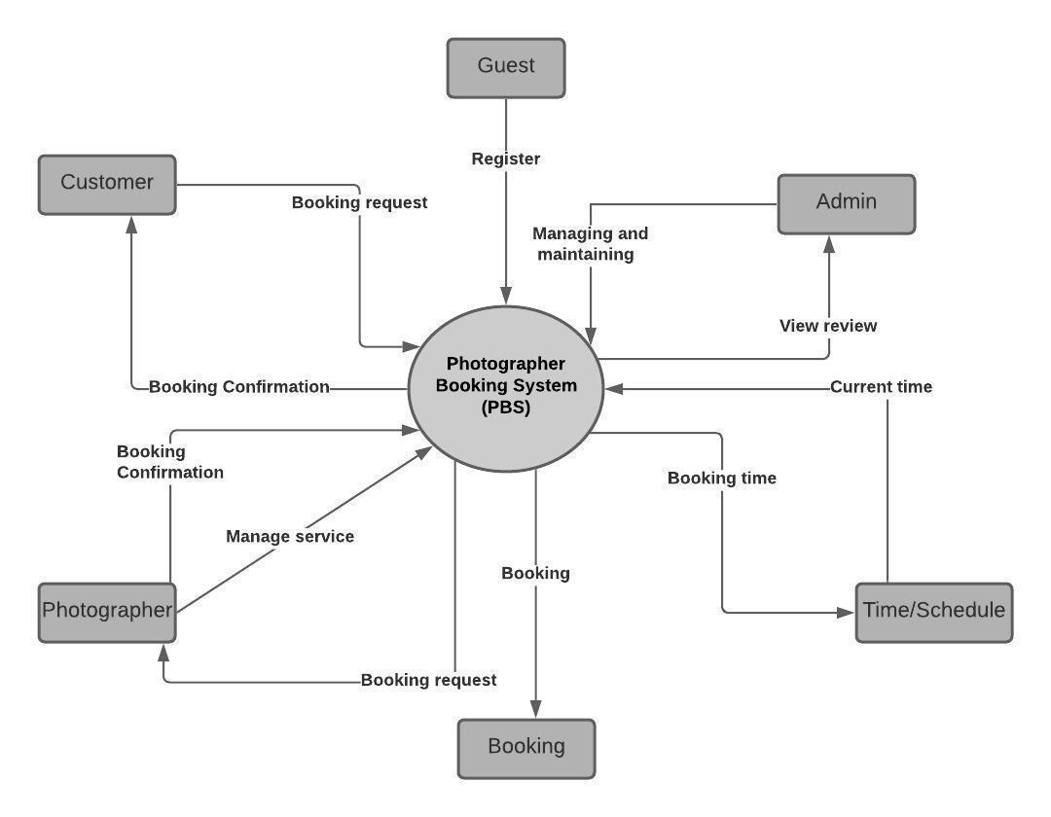

***Figure 1 - Context Diagram***

### 1.2 Business Rules

|  |  |
| --- | --- |
| **ID** | **Rule Definition** |
| BR-01 | Photographers have to update their customers’ request status within 24 hours. |
| BR-02 | Customers can only book photographers within 3 months. |
| BR-03 | Customers cannot remove the reviews they have made. |
| BR-04 | After making a request, the customer can update information related to that request before the photographer confirms it. |
| BR-05 | Customers can cancel a booking request when the request’s status is “Pending” or “Upcoming”. |
| BR-06 | If a customer cancels a request with status “Upcoming”, he/she must give a reason and wait for the photographer to confirm. |
| BR-07 | The time for a new request cannot be in the past. |
| BR-08 | Photographers cannot remove their customers’ reviews. |
| BR-09 | The admin locks users when they violate business rules. |
| BR-10 | Administrators are not permitted to write reviews and rate for photographers. |
| BR-11 | Administrators are not permitted to remove photographers’ comments. |
| BR-12 | Only the admin can add a shooting category. |
| BR-13 | Only the admin can edit the shooting category. |
| BR-14 | Only the admin can remove the shooting category. |
| BR-15 | After a new request is made for a photographer, other customers cannot make a new request to that photographer with the same schedule. |
| BR-16 | If customers want to cancel a request with status “Upcoming”, they have to do it within 24 hours. |

***Table 1 - Business rules***

## 2. User Requirements

### 2.1 Overview

#### a. Use Case Diagram

***Figure 2 - Use Case Diagram***

#### b. System Actors

|  |  |  |
| --- | --- | --- |
| **#** | **Actor** | **Description** |
| 1 | Administrator | The role who manages the whole system |
| 2 | Photographer | The person who receives customers’ requests and their reviews. Photographers will confirm the received requests, inform the customers about shooting day, photos returning day. They will provide services, photos for the system. |
| 3 | Customer | The person who searches for a photographer and sends a request to him. They will receive notifications about the request confirmation, shooting day, photos returning day. They can write reviews about photographers’ service quality after the requests are done. |
| 4 | Guest | The person who can register an account and will receive a response from the system. |

Table 2 - System Actors

#### c. Use Cases List

|  |  |  |  |
| --- | --- | --- | --- |
| **ID** | **Use Case** | **Primary Actors** | **Secondary Actors** |
| 01 | Register | Guest |  |
| 02 | Login  (Login with google, Login with facebook) | Guest |  |
| 03 | Search photographer | Customer |  |
| 04 | Get photographer’s detail | Customer |  |
| 05 | Book Photographer | Customer |  |
| 06 | Review photographer | Customer |  |
| 07 | Make notification  (Make booking notification) | Customer, Photographer, Handler |  |
| 08 | Get booking  (Cancel, Edit, Accept, Decline) | Customer, Photographer |  |
| 09 | Chat | Customer, Photographer |  |
| 10 | Discuss on forum  (Open thread, Edit thread, Comment thread, Follow thread) | Customer, Photographer, Admin |  |
| 11 | Edit working calendar | Photographer |  |
| 12 | Get customer’s review | Photographer, Admin |  |
| 13 | Manage service  (Add, Edit, Remove) | Photographer |  |
| 14 | Manage album  (Add, Edit, Remove) | Photographer |  |
| 15 | Manage delivery method | Admin |  |
| 16 | Manage variables | Admin |  |
| 17 | Manage user  (Get user’s activity, Unblock user, Block user) | Admin |  |
| 18 | Manage shooting category  (Add, Edit, Remove) | Admin |  |
| 19 | Get profile  (Edit profile) | Authenticated User |  |
| 20 | Logout | Authenticated User |  |
| 21 | Change password | Authenticated User |  |

***Table 3 - Use Case List***

### 2.2 List of use case

#### a. <Guest > Overview use case

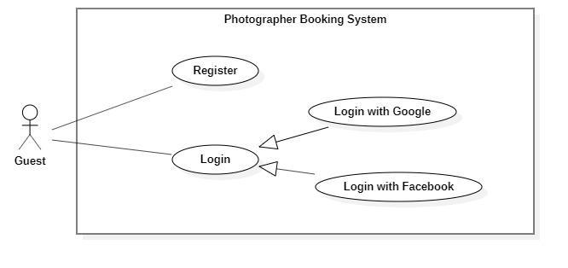

***Figure 3 - <Guest> Overview Use Case***

1. ***<Guest> Register***

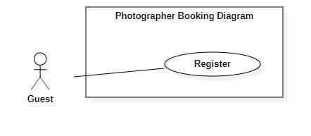

***Figure 4 - <Guest> Register***

|  |  |  |  |
| --- | --- | --- | --- |
| UC ID and Name: | **PBS-UC-01 Register** | | |
| Created By: | Truong Ngoc My | Date Created: | 08/10/2020 |
| Primary Actor: | Guest | Secondary Actors: |  |
| Trigger: | The Guest taps “Đăng ký” on “Đăng nhập” screen | | |
| Description: | The guest wants to register an account. | | |
| Preconditions: | - Guests launch mobile applications.  - Guest is at the “Đăng nhập” screen.  - Guests have connected to the Internet. | | |
| Post-conditions: | Success: The guest registers an account as a customer or photographer. | | |
| Normal Flow: | |  |  |  | | --- | --- | --- | | **Step** | **Actor Action** | **System Response** | | 1 | The Guest taps “Đăng kí” on “Đăng nhập” screen. | The system shows a “Thông tin đăng ký” screen with the following inputs.  - “Họ và tên”: text input, required.  - “Tên đăng nhập”: text input, required  - “Mật khẩu”: password input, required.  - “Xác nhận mật khẩu”: password input, required.  - “Số điện thoại”: phone number input.  - “Email”: text input, required. | | 2 | The guest taps the “Đăng kí” button. | - The system validates inputted data [Exception 1,2,3,4,5,6].  - The system shows the “Đăng nhập” screen. | | | |
| Alternative Flows: | N/A | | |
| Exceptions: | |  |  |  | | --- | --- | --- | | **No** | **Actor Action** | **System Response** | | 1 | - “Họ và tên” is empty  - “Tên đăng nhập” is empty  - “Mật khẩu” is empty  - “Xác nhận mật khẩu” is empty.  - “Số điện thoại” is empty  - “Email” is empty | System shows an error message: “Thông tin này là bắt buộc” | | 2 | Password and Confirm password are not matched. | System shows an error message: “Mật khẩu nhập lại không khớp”. | | 3 | Register successfully | System shows an error message: “Đăng ký thành công”. | | 4 | “Email” Is invalid | System shows an error message:  “Email mail này không hợp lệ. Vui lòng nhập email khác.” | | 5 | - “Tên đăng nhập” not enough character.  - “Mật khẩu” not enough character. | System shows an error message:  “Bạn vui lòng nhập đủ 8 – 16 ký tự.” | | 6 | “Tên đăng nhập” is exist. | System shows an error message:  “Tên đăng nhập của bạn đã có người sử dụng. Vui lòng nhập tên khác.” | | | |
| Priority: | Medium | | |
| Frequency of Use: | Always | | |
| Business Rules: |  | | |
| Other Information: | N/A | | |
| Assumptions: |  | | |

***Table 4 - <Guest> Register use case specification***

1. ***<Guest> Login***

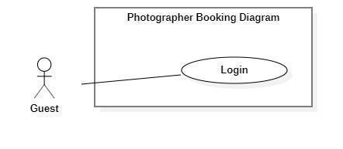

***Figure 5 - <Guest> Login***

|  |  |  |  |
| --- | --- | --- | --- |
| UC ID and Name: | **PBS-UC-02 Login** | | |
| Created By: | Truong Ngoc My | Date Created: | 08/10/2020 |
| Primary Actor: | Guest | Secondary Actors: |  |
| Trigger: | The Guest taps “Đăng nhập” on “Đăng nhập” screen | | |
| Description: | The guest wants to login to the system. | | |
| Preconditions: | - Guests launch mobile applications.  - Guest is at the “Đăng nhập” screen.  - Guests have connected to the Internet. | | |
| Post-conditions: | Success: The guest login to the system. | | |
| Normal Flow: | |  |  |  | | --- | --- | --- | | **Step** | **Actor Action** | **System Response** | | 1 | The Guest opened a mobile app. | “Đăng nhập” screen is show with the following inputs:  - “Tên đăng nhập”: text input, required  - “Mật khẩu”: password input, required.  - “Đăng nhập”: button  - “Đăng ký”: button  - “Login with google”: button  - “Login with facebook”: button | | 2 | The guest inputs the name and password and taps the “Đăng nhập” button. | - The system validates inputted data [Exception 1,2]  - The system shows the main screen. | | | |
| Alternative Flows: | N/A | | |
| Exceptions: | |  |  |  | | --- | --- | --- | | No | Actor Action | System Response | | 1 | - “Tên đăng nhập” is empty  - “Mật khẩu” is empty | System shows an error message: “Thông tin này là bắt buộc” | | 2 | Name and Password is incorrect. | System shows an error message: “Thông tin đăng nhập không chính xác”. | | | |
| Priority: | Medium | | |
| Frequency of Use: | Always | | |
| Business Rules: |  | | |
| Other Information: | N/A | | |
| Assumptions: |  | | |

***Table 5 - <Guest> Login use case specification***

1. ***<Guest> Login with Google***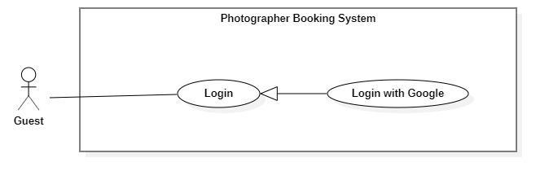

**Figure 1 - <Guest> Overview login with Google**

|  |  |  |  |
| --- | --- | --- | --- |
| UC ID and Name: | **PBS-UC-03 Login with google** | | |
| Created By: | Truong Ngoc My | Date Created: | 08/10/2020 |
| Primary Actor: | Guest | Secondary Actors: |  |
| Trigger: | The Guest taps “Login with google” on “Đăng nhập” screen | | |
| Description: | The guest wants to login to the system. | | |
| Preconditions: | - Guests launch mobile applications.  - Guest is at the “Đăng nhập” screen.  - Guests have connected to the Internet. | | |
| Post-conditions: | Success: The guest login with google to the system. | | |
| Normal Flow: | |  |  |  | | --- | --- | --- | | **Step** | **Actor Action** | **System Response** | | 1 | The Guest opened a mobile app. | “Đăng nhập” screen is show with the following inputs:  - “Tên đăng nhập”: text input, required  - “Mật khẩu”: password input, required.  - “Đăng nhập”: button  - “Đăng ký”: button  - “Login with google”: button  - “Login with facebook”: button | | 2 | The guest clicks “Login with google”. | - The system show popup “Choose an account”, the following inputs: [Exception 1, 2]  + “Enter password”: text, hiden  + “Next”: button | | 3 | The guest clicks the “Next” button. | - The system shows the main screen. | | | |
| Alternative Flows: | N/A | | |
| Exceptions: | |  |  |  | | --- | --- | --- | | No | Actor Action | System Response | | 1 | - “Enter password” is empty | System shows an error message: “Thông tin này là bắt buộc” | | 2 | Password is incorrect. | System shows an error message: “Mật khẩu không chính xác”. | | | |
| Priority: | High | | |
| Frequency of Use: | Always | | |
| Business Rules: |  | | |
| Other Information: | N/A | | |
| Assumptions: |  | | |

**Table 1 - <Guest> Login with google use case specification**

1. ***<Guest> Login with facebook***

**Figure 2 - <Guest> Overview login with facebook**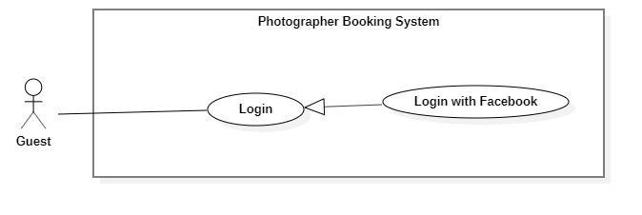

|  |  |  |  |
| --- | --- | --- | --- |
| UC ID and Name: | **PBS-UC-03 Login with google** | | |
| Created By: | Truong Ngoc My | Date Created: | 08/10/2020 |
| Primary Actor: | Guest | Secondary Actors: |  |
| Trigger: | The Guest taps “Login with google” on “Đăng nhập” screen | | |
| Description: | The guest wants to login to the system. | | |
| Preconditions: | - Guests launch mobile applications.  - Guest is at the “Đăng nhập” screen.  - Guests have connected to the Internet. | | |
| Post-conditions: | Success: The guest login with google to the system. | | |
| Normal Flow: | |  |  |  | | --- | --- | --- | | **Step** | **Actor Action** | **System Response** | | 1 | The Guest opened a mobile app. | “Đăng nhập” screen is show with the following inputs:  - “Tên đăng nhập”: text input, required  - “Mật khẩu”: password input, required.  - “Đăng nhập”: button  - “Đăng ký”: button  - “Login with google”: button  - “Login with facebook”: button | | 2 | The guest click “Login with facebook”. | - The system show popup “facebook name”, the following inputs: [Exception 1, 2]  + “Enter password”: text, hiden  + “Next”: button | | 3 | The guest clicks the “Next” button. | - The system shows the main screen. | | | |
| Alternative Flows: | N/A | | |
| Exceptions: | |  |  |  | | --- | --- | --- | | No | Actor Action | System Response | | 1 | - “Enter password” is empty | System shows an error message: “Thông tin này là bắt buộc” | | 2 | Password is incorrect. | System shows an error message: “Mật khẩu không chính xác”. | | | |
| Priority: | High | | |
| Frequency of Use: | Always | | |
| Business Rules: |  | | |
| Other Information: | N/A | | |
| Assumptions: |  | | |

**Table 2 - <Guest> Login with facebook use case specification**

#### b. <Customer> Overview use case

***Figure 6 - <Customer> Overview use case***

1. ***<Customer> Search Photographer***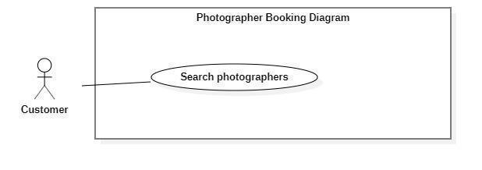

***Figure 7 - <Customer> Search Photographer***

|  |  |  |  |
| --- | --- | --- | --- |
| UC ID and Name: | **PBS-UC-04 Search photographer** | | |
| Created By: | Truong Ngoc My | Date Created: | 08/10/2020 |
| Primary Actor: | Customer | Secondary Actors: |  |
| Trigger: | The customer sends request to find photographers | | |
| Description: | The customer needs to find photographers. | | |
| Preconditions: | - The customer has been authenticated.  - The customer has accessed the Internet. | | |
| Post-conditions: | Success: A list of photographers is shown.  Fail: System shows error messages. | | |
| Normal Flow: | |  |  |  | | --- | --- | --- | | **Step** | **Actor Action** | **System Response** | | 1 | The customer input name photographer or service name after clicking the search icon button. | - The system validates inputted data.  - The system shows a list photographer or service name. | | | |
| Alternative Flows: | N/A | | |
| Exceptions: | N/A | | |
| Priority: | Medium | | |
| Frequency of Use: | Sometimes | | |
| Business Rules: | N/A | | |
| Other Information: | The customer can view a list of available photographers and categories of the main screen. | | |
| Assumptions: |  | | |

***Table 6 - <Customer> Search photographer use case specification***

1. ***<Customer> Get photographer’s detail***

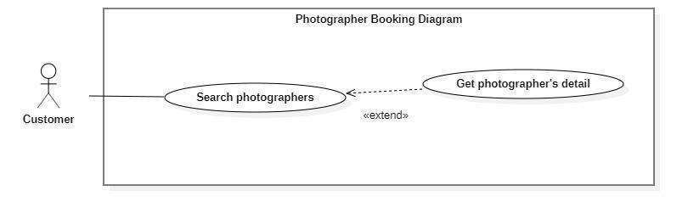

***Figure 8 - <Customer> Get photographer's Detail***

|  |  |  |  |
| --- | --- | --- | --- |
| UC ID and Name: | **PBS-UC-05 Get photographer’s detail** | | |
| Created By: | Truong Ngoc My | Date Created: | 08/10/2020 |
| Primary Actor: | Customer | Secondary Actors: |  |
| Trigger: | The customer taps the photographer or photographer icon. | | |
| Description: | The customer needs to view the profile of the photographer. | | |
| Preconditions: | - The customer has been authenticated.  - The customer has opened location service.  - The customer has accessed the Internet.  - The customer is at the “Danh sách photographer” screen. | | |
| Post-conditions: | Success: The system showed the photographer’s page. | | |
| Normal Flow: | |  |  |  | | --- | --- | --- | | **Step** | **Actor Action** | **System Response** | | 1 | The customer taps on the photographer on the result of a list photographer search or photographer view main screen. | The system shows the photographer profile screen with the following information:  - “Mô tả”: introduction or a brief description.  - “Đánh giá” number of people and number of stars: number of bookings.  - “Các album”: album photo of photographer.  - “Nhận xét”: list of feedbacks.  - “Lịch của photographer”: schedule of photographer.  - “Chọn gói dịch vụ bạn muốn”: list of service of photographer, choose option, required.  - “tiếp tục”: button | | | |
| Alternative Flows: | N/A | | |
| Exceptions: | N/A | | |
| Priority: | High | | |
| Frequency of Use: | Always | | |
| Business Rules: | BR-04 | | |
| Other Information: | N/A | | |
| Assumptions: |  | | |

***Table 7 - <Customer> Get photographer's detail use case specification***

1. ***<Customer> Book photographer***

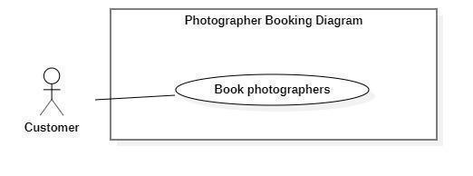

***Figure 9 - <Customer> Book photographer***

|  |  |  |  |
| --- | --- | --- | --- |
| UC ID and Name: | **PBS-UC-06 Book photographer** | | |
| Created By: | Truong Ngoc My | Date Created: | 08/10/2020 |
| Primary Actor: | Customer | Secondary Actors: |  |
| Trigger: | The customer taps the “Tiếp tục” button. | | |
| Description: | The customer can book a photographer. | | |
| Preconditions: | - The customer has been authenticated.  - The customer has selected a photographer and viewed their profile photographer.  - The customer has accessed the Internet. | | |
| Post-conditions: | Success: The system sends requests to the photographer. | | |
| Normal Flow: | |  |  |  | | --- | --- | --- | | **Step** | **Actor Action** | **System Response** | | 1 | The customer taps “Tiếp tục” button after click choose “Gói chụp trong ngày”. | The system shows the “Đặt lịch với photographer” screen. The customer input following:  - “Photographer”: default.  - “Thời gian chụp”: The customer can choose date and start time.  - “Thời gian nhận ảnh”: choose date.  - “Địa điểm”: input text, required.  - “Phương thức nhận ảnh”: choose a method.  - “Gói dịch vụ”: the customer can change.  - “Tổng cộng”: price.  - “Đặt dịch vụ”: button | | 2 | The customer taps “Đặt dịch vụ” button | - The system validates inputted data  - The system creates a new request and notifies the chosen photographer. [Exception 1,2] | | | |
| Alternative Flows: | |  |  |  | | --- | --- | --- | | **Step** | **Actor Action** | **System Response** | | 1 | The customer taps “Tiếp tục” button after click choose “Gói chụp nhiều ngày”. | The system shows the “Đặt lịch với photographer” screen. The customer input following:  - “Photographer”: default.  - “Thời gian chụp”: The customer can choose date and start time.  - “Thời gian nhận”: choose date.  - “Địa điểm”: input text, required.  - “Gói dịch vụ”: the customer can change.  - “Phương thức nhận ảnh”: choose a method.  - “Tổng cộng”: price.  - “Đặt dịch vụ”: button | | 2 | The customer taps “Đặt dịch vụ” button | - The system validates inputted data  - The system creates a new request and notifies the chosen photographer. [Exception 1,2] | | | |
| Exceptions: | |  |  |  | | --- | --- | --- | | **No** | **Actor Action** | **System Response** | | 1 | The customer book photographer successfully. | System shows an error message: “Gửi yêu cầu thành công” | | 2 | The customer do not choose “Thời gian chụp”, “Thời gian nhận” and “Địa điểm”. | System shows an error message: “Bạn chưa chọn thông tin” | | | |
| Priority: | High | | |
| Frequency of Use: | Sometimes | | |
| Business Rules: | BR-01, BR-02, BR-07, BR-15 | | |
| Other Information: | N/A | | |
| Assumptions: |  | | |

***Table 8 - <Customer> Book photographer use case specification***

1. ***<Customer> Review photographers***

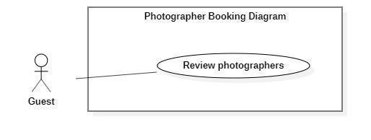

***Figure 10 - <Customer> Review photographers***

|  |  |  |  |
| --- | --- | --- | --- |
| UC ID and Name: | **PBS-UC-07 Review photographers** | | |
| Created By: | Truong Ngoc My | Date Created: | 08/10/2020 |
| Primary Actor: | Customer | Secondary Actors: |  |
| Trigger: | The customer taps “Đánh giá” to request a successful history. | | |
| Description: | The customer needs to write a comment and rating to the photographer service. | | |
| Preconditions: | - The customer has been authenticated.  - The customer book photographer successfully.  - The customer has accessed the Internet. | | |
| Post-conditions: | Success: The system shows comments and ratings of the customer on the photographer page. | | |
| Normal Flow: | |  |  |  | | --- | --- | --- | | **Step** | **Actor Action** | **System Response** | | 1 |  | After the request’s status is updated to “Đã hoàn thành”, “Đánh giá” button and “Bỏ qua” button is shown. | | 2 | The customer taps “Đánh giá” button | The system will go to “Nhận xét” on the photographer page. The customer input with the following:  - star icon: The customer choose star  - “Bình luận”: Text input, optional | | 3 | The customer taps “Gửi” button | - The system validates inputted data [Exception1,2]  - The system shows comments and ratings of customers. | | | |
| Alternative Flows: | N/A | | |
| Exceptions: | |  |  |  | | --- | --- | --- | | **No** | **Actor Action** | **System Response** | | 1 | Enter many characters. | System shows an error message:  “Bạn chỉ được nhập tối đa 150 ký tự” | | 2 | Enter less character. | System shows an error message:  “Bạn phải nhập tối thiểu 50 ký tự”. | | | |
| Priority: | High | | |
| Frequency of Use: | Sometimes | | |
| Business Rules: | BR-03 | | |
| Other Information: | N/A | | |
| Assumptions: |  | | |

***Table 9 - <Customer> Review photographers use case specification***

1. ***<Customer> Get booking***

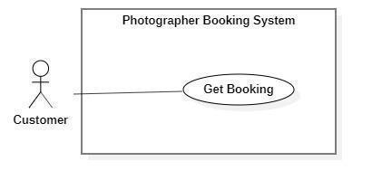

**Figure 11 - <Customer> Get booking**

|  |  |  |  |
| --- | --- | --- | --- |
| UC ID and Name: | **PBS-UC-08 Get booking** | | |
| Created By: | Tran Thien Thao | Date Created: | 08/10/2020 |
| Primary Actor: | Customer | Secondary Actors: | Photographer |
| Trigger: | The customer navigates to the “Hoat động” screen. | | |
| Description: | The customer can view all requests of theirs. | | |
| Preconditions: | - The customer has been authenticated.  - The customer has accessed the Internet.  - The customer book photographer. | | |
| Post-conditions: | Success: The customer can view request history. | | |
| Normal Flow: | |  |  |  | | --- | --- | --- | | **Step** | **Actor Action** | **System Response** | | 1 | The customer navigates to the “Lịch sử” screen. | The system shows a list of requests the customer has made. | | | |
| Alternative Flows: | N/A | | |
| Exceptions: | N/A | | |
| Priority: | Low | | |
| Frequency of Use: | Sometimes | | |
| Business Rules: | N/A | | |
| Other Information: | N/A | | |
| Assumptions: |  | | |

***Table 10 - <Customer> Get booking use case specification***

1. ***<Customer> Edit Booking***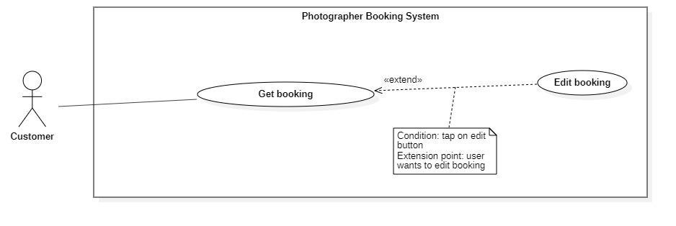

***Figure 12 - <Customer> Edit booking***

|  |  |  |  |
| --- | --- | --- | --- |
| UC ID and Name: | **PBS-UC-09 Edit booking** | | |
| Created By: | Tran Thien Thao | Date Created: | 08/10/2020 |
| Primary Actor: | Customer | Secondary Actors: |  |
| Trigger: | The customer taps on “Thay đổi” button in the request “Chờ xác nhận”. | | |
| Description: | The customer needs to change information on request. | | |
| Preconditions: | - The customer has been authenticated.  - The customer has accessed the Internet.  - The status of request is “Chờ xác nhận”. | | |
| Post-conditions: | Success: The customer changes a request successfully and the system sends a request to the photographer. | | |
| Normal Flow: | |  |  |  | | --- | --- | --- | | **Step** | **Actor Action** | **System Response** | | 1 | The customer taps “Chờ xác nhận” request. | The system shows the “Thông tin hoạt động” screen:  - “Trạng thái, thời gian & địa điểm” to include: “Trạng thái”, “Thời gian”, “Thời gian tác nghiệp dự kiến”, “Thời gian nhận ảnh”, “Địa điểm”.  - “Thông tin photographer”: name photographer and rating.  - “Thông tin gói dịch vụ” to include: “tên gói”, “Mô tả”, “Bao gồm các dịch vụ”, “Tổng cộng”  - “Phương thức nhận ảnh”  - “Thay đổi”: button  - “Hủy”: button | | 2 | The customer taps “Thay đổi” button on the item. | The system shows the “Thông tin đặt lịch” screen. The customer input following:  - “Photographer”: default.  - “Thời gian chụp”: The customer can choose date and start time.  - “Thời gian nhận”: choose date.  - “Địa điểm”: input text, required.  - “Gói dịch vụ”: the customer can change.  - “Phương thức nhận ảnh”  - “Tổng cộng”: price.  - “Xác nhận”: button  - “Hủy”: button | | 3 | The customer taps the “Xác nhận” button. | - The system validates inputted data [Exception 2]  - The system creates a new request and notifies the chosen photographer. [Exception 1] | | | |
| Alternative Flows: | N/A | | |
| Exceptions: | |  |  |  | | --- | --- | --- | | **No** | **Actor Action** | **System Response** | | 1 | The customer book photographer successfully. | System shows an error message: “Gửi yêu cầu thành công” | | 2 | The customer does not choose “Thời gian” and “Địa điểm”. | System shows an error message: “Bạn chưa chọn thông tin” | | | |
| Priority: | Medium | | |
| Frequency of Use: | Sometimes | | |
| Business Rules: | BR-02, BR-04, BR-07, BR-15 | | |
| Other Information: | N/A | | |
| Assumptions: |  | | |

***Table 11- <Customer> Edit booking use case specification***

1. ***<Customer> Cancel booking***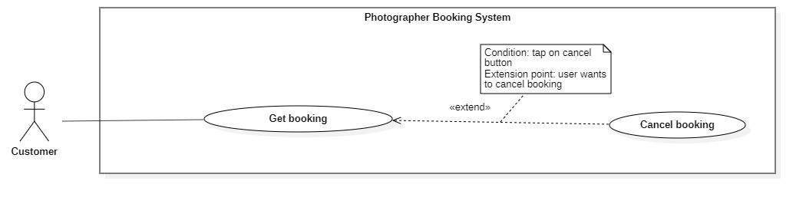

***Figure 13 - <Customer> Cancel booking***

|  |  |  |  |
| --- | --- | --- | --- |
| UC ID and Name: | **PBS-UC-11 Cancel booking** | | |
| Created By: | Tran Thien Thao | Date Created: | 08/10/2020 |
| Primary Actor: | Customer | Secondary Actors: |  |
| Trigger: | The customer taps “Hủy” button on the booking detail. | | |
| Description: | The customer needs to cancel their booking. | | |
| Preconditions: | - The customer has been authenticated.  - The customer has accessed the Internet.  - The status of request is “Chờ xác nhận” or “Sắp diễn ra”. | | |
| Post-conditions: | Success: the customer cancels booking successfully. | | |
| Normal Flow: | |  |  |  | | --- | --- | --- | | **Step** | **Actor Action** | **System Response** | | 1 | The customer taps “Chờ xác nhận” request. | The system shows the “Thông tin hoạt động” screen:  - “Trạng thái, thời gian & địa điểm” to include: “Trạng thái”, “Thời gian”, “Thời gian tác nghiệp dự kiến”, “Thời gian nhận ảnh”, “Địa điểm”.  - “Thông tin photographer”: name photographer and rating.  - “Thông tin gói dịch vụ” to include: “tên gói”, “Mô tả”, “Bao gồm các dịch vụ”, “Tổng cộng”  - “Phương thức nhận ảnh”  - “Thay đổi”: button  - “Hủy”: button | | 2 | The customer taps “Hủy” button. | The system shows notifies the chosen customer: [Exception 2]  - “Có”: button  - “Không”: button | | 3 | The customer taps the “Có” button. | - The system update requests the chosen photographer. | | | |
| Alternative Flows: | |  |  |  | | --- | --- | --- | | **Step** | **Actor Action** | **System Response** | | 1 | The customer taps the “Sắp diễn ra” request. | The system shows the “Thông tin hoạt động” screen:  - “Trạng thái, thời gian & địa điểm” to include: “Trạng thái”, “Thời gian”, “Thời gian tác nghiệp dự kiến”, “Thời gian nhận ảnh”, “Địa điểm”.  - “Thông tin photographer”: name photographer and rating.  - “Thông tin gói dịch vụ” to include: “tên gói”, “Mô tả”, “Bao gồm các dịch vụ”, “Tổng cộng”  - “Phương thức nhận ảnh”  - “Thay đổi”: button  - “Hủy”: button | | 2 | The customer taps “Hủy” button. | The system shows notifies the chosen customer: [Exception 2]  - “Có”: button  - “Không”: button | | 3 | The customer taps the “Có” button. | - The system update requests the chosen photographer. | | 4 |  | The system shows “Hủy cuộc hẹn” popup. The customer input following:  -” Hủy cuộc hẹn”: input text “Lý do hủy cuộc hẹn của bạn là gì”, required.  - “xác nhận”: button | | 5 | The customer input the reason and taps the “Xác nhận” button. | The system update requests the chosen photographer. | | | |
| Exceptions: | |  |  |  | | --- | --- | --- | | **No** | **Actor Action** | **System Response** | | 1 | The customer taps “Hủy” button. | System shows an error message: “Bạn có muốn hủy lần đặt photographer này không?” | | | |
| Priority: | High | | |
| Frequency of Use: | Sometimes | | |
| Business Rules: | BR-05, BR-06, BR-16 | | |
| Other Information: | N/A | | |
| Assumptions: |  | | |

***Table 12 - <Customer>Cancel booking use case specification***

1. ***<Customer> Chat***

**Figure 3 - <Customer> Chat**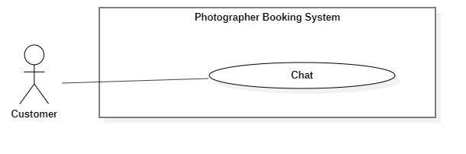

|  |  |  |  |
| --- | --- | --- | --- |
| UC ID and Name: | **PBS-UC-12 Chat** | | |
| Created By: | Tran Thien Thao | Date Created: | 08/10/2020 |
| Primary Actor: | Customer, photographer | Secondary Actors: | Photographer |
| Trigger: | The customer clicks the “Chat” icon. | | |
| Description: | The customer chatted with the photographer. | | |
| Preconditions: | - The customer has been authenticated.  - The customer has accessed the Internet.  - The customer book photographer. | | |
| Post-conditions: | Success: The customer can chat with the photographer. | | |
| Normal Flow: | |  |  |  | | --- | --- | --- | | **Step** | **Actor Action** | **System Response** | | 1 | The customer clicks the “Chat” icon. | The system shows a “Chat” screen. | | | |
| Alternative Flows: | N/A | | |
| Exceptions: | N/A | | |
| Priority: | Low | | |
| Frequency of Use: | Sometimes | | |
| Business Rules: | N/A | | |
| Other Information: | N/A | | |
| Assumptions: |  | | |

**Table 3 - <Customer> Chat use case specification**

1. ***<Customer> Make booking notification***

**Figure 4 - <Customer> Overview make booking notification**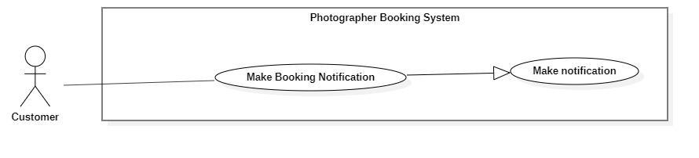

|  |  |  |  |
| --- | --- | --- | --- |
| UC ID and Name: | **PBS-UC-13 Make booking notification** | | |
| Created By: | Dao Sy Trung Kien | Date Created: | 08/10/2020 |
| Primary Actor: | Customer, Photographer | Secondary Actors: | System handler |
| Trigger: | The customer sends a request to the photographer.  The photographers respond to requests for customers. | | |
| Description: | The customer receives notices of his request sent to the photographer and also is the photographer. | | |
| Preconditions: | - The customer sends a request successfully. | | |
| Post-conditions: | Success: The system make booking notification and sends to the customer | | |
| Normal Flow: | |  |  |  | | --- | --- | --- | | **Step** | **Actor Action** | **System Response** | | 1 | System handler retrieves make booking notifications. | The system stores requests and makes notification information to return to the system's handler. | | 2 | System handler retrieves notification information and sends it to customers. |  | | | |
| Alternative Flows: | N/A | | |
| Exceptions: | |  |  |  | | --- | --- | --- | | No | Actor Action | System Response | | 1 | Make notification process encountered an internal error. | Error details will be tracked in the log file. System outputs error messages and sends them to the user. | | | |
| Priority: | Low | | |
| Frequency of Use: | Sometimes | | |
| Business Rules: | N/A | | |
| Other Information: | N/A | | |
| Assumptions: |  | | |

**Table 4 - <Customer> Make booking notification use case specification**

1. ***<Customer> Open thread***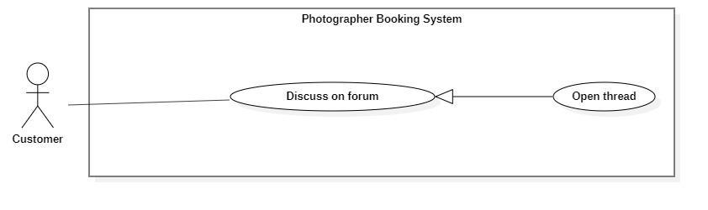

**Figure 5 - <Customer> Overview open thread**

|  |  |  |  |
| --- | --- | --- | --- |
| UC ID and Name: | **PBS-UC-15 Open thread** | | |
| Created By: | Tran Thien Thao | Date Created: | 08/10/2020 |
| Primary Actor: | Customer, Photographer, Admin | Secondary Actors: |  |
| Trigger: | The customer navigates to the “Diễn đàn” screen after choosing the add icon. | | |
| Description: | The customer opens the thread. | | |
| Preconditions: | - The customer has been authenticated.  - The customer has accessed the Internet. | | |
| Post-conditions: | Success: The customer can open a thread. | | |
| Normal Flow: | |  |  |  | | --- | --- | --- | | **Step** | **Actor Action** | **System Response** | | 1 | The customer navigates to the “Diễn đàn” screen. | The system shows “Diễn đàn” screen”.  - “Xu hướng gần đây”: main topic.  - “Gần đây nhất”: main topic.  - “Danh mục”: category.  - “Add” icon. | | 2 | The customer clicks the “Add” icon. | The system shows “Chủ đề mới” screen. The following inputs:  - “Chủ đề”: choose a method.  - “Tên chủ đề”: text, required.  - “Bình luận của bạn”: text, required  - “Hình ảnh”: choose the picture  - “V”: button | | 3 | The customer clicks the “V” button. | - The system shows a message.  - The system shows thread. | | | |
| Alternative Flows: | N/A | | |
| Exceptions: | |  |  |  | | --- | --- | --- | | **No** | **Actor Action** | **System Response** | | 1 | The customer opens the thread successfully. | System shows an error message: “Thêm chủ đề thành công” | | 2 | “Chủ đề”, “Tên chủ đề” and “Bình luận của bạn” is empty. | System shows an error message: “Bạn chưa chọn thông tin” | | | |
| Priority: | Low | | |
| Frequency of Use: | Sometimes | | |
| Business Rules: | N/A | | |
| Other Information: | N/A | | |
| Assumptions: |  | | |

**Table 5 - <Customer> Open thread use case specification**

1. ***<Customer> Edit thread***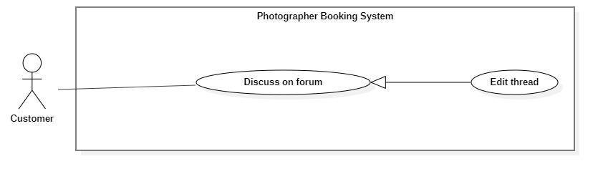

**Figure 6 - <Customer> Overview edit thread**

|  |  |  |  |
| --- | --- | --- | --- |
| UC ID and Name: | **PBS-UC-16 Edit thread** | | |
| Created By: | Tran Thien Thao | Date Created: | 08/10/2020 |
| Primary Actor: | Customer, Photographer, Admin | Secondary Actors: |  |
| Trigger: | The customer navigates to the “Diễn đàn” screen after choosing the edit thread. | | |
| Description: | The customer edit thread. | | |
| Preconditions: | - The customer has been authenticated.  - The customer has accessed the Internet.  - The customer opened the thread. | | |
| Post-conditions: | Success: The customer can edit the thread. | | |
| Normal Flow: | |  |  |  | | --- | --- | --- | | **Step** | **Actor Action** | **System Response** | | 1 | The customer navigates to the “Diễn đàn” screen. | The system shows “Diễn đàn” screen”.  - “Xu hướng gần đây”: main topic.  - “Gần đây nhất”: main topic.  - “Danh mục”: category.  - “Add” icon. | | 2 | The customer click thread want to edit after click “Điều hành” button. | The system shows a thread screen. The following inputs:  - “Chủ đề”: choose a method.  - “Tên chủ đề”: text, required.  - “Bình luận của bạn”: text, required  - “Hình ảnh”: choose the picture  - “V”: button | | 3 | The customer clicks the “V” button. | - The system shows a message.  - The system shows thread. | | | |
| Alternative Flows: | N/A | | |
| Exceptions: | |  |  |  | | --- | --- | --- | | **No** | **Actor Action** | **System Response** | | 1 | The customer edit thread successfully. | System shows an error message: “Chỉnh sửa thành công” | | 2 | “Chủ đề”, “Tên chủ đề” and “Bình luận của bạn” is empty. | System shows an error message: “Bạn chưa chọn thông tin” | | | |
| Priority: | Low | | |
| Frequency of Use: | Sometimes | | |
| Business Rules: | N/A | | |
| Other Information: | N/A | | |
| Assumptions: |  | | |

**Table 6 - <Customer> Edit thread use case specification**

1. ***<Customer> Comment thread***

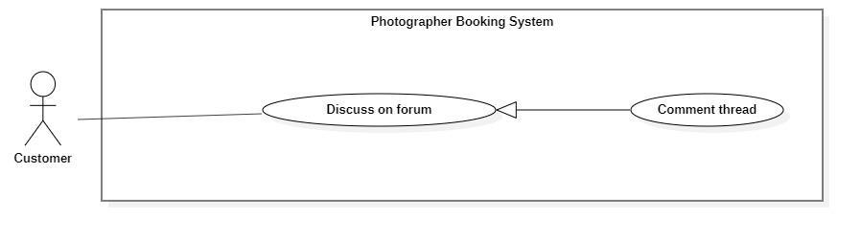

**Figure 7 - <Customer> Overview comment thread**

|  |  |  |  |
| --- | --- | --- | --- |
| UC ID and Name: | **PBS-UC-17 Comment thread** | | |
| Created By: | Tran Thien Thao | Date Created: | 08/10/2020 |
| Primary Actor: | Customer, Photographer, Admin | Secondary Actors: |  |
| Trigger: | The customer navigates to the “Diễn đàn” screen after choosing the thread want to comment on. | | |
| Description: | The customer comment thread. | | |
| Preconditions: | - The customer has been authenticated.  - The customer has accessed the Internet. | | |
| Post-conditions: | Success: The customer can comment thread. | | |
| Normal Flow: | |  |  |  | | --- | --- | --- | | **Step** | **Actor Action** | **System Response** | | 1 | The customer navigates to the “Diễn đàn” screen. | The system shows “Diễn đàn” screen”.  - “Xu hướng gần đây”: main topic.  - “Gần đây nhất”: main topic.  - “Danh mục”: category.  - “Add” icon. | | 2 | The customer click thread wants to comment. | The system shows a thread screen. The following inputs:  - “Chủ đề”: choose a method.  - “Tên chủ đề”: text, required.  - “Nội dung”: text.  - “Bình luận”: text.  - “Bình luận”: button | | 3 | The customer clicks the “Bình luận” button. | - The system shows “Trả lời: screen. The following input:  + “Viết bình luận của bạn”: text, required.  + “Hình ảnh”: choose the picture.  + “V”: button. | | 4 | The customer clicks the “V” button. | - The system shows a message.  - The system shows comments in the thread. | | | |
| Alternative Flows: | N/A | | |
| Exceptions: | |  |  |  | | --- | --- | --- | | **No** | **Actor Action** | **System Response** | | 1 | The customer comment thread successfully. | System shows an error message: “Bình luận thành công” | | 2 | “Viết bình luận của bạn” is empty | System shows an error message: “Thông tin này là bắt buộc” | | | |
| Priority: | Low | | |
| Frequency of Use: | Sometimes | | |
| Business Rules: | N/A | | |
| Other Information: | N/A | | |
| Assumptions: |  | | |

**Table 7 - <Customer> Comment thread use case specification**

1. ***<Customer> Follow thread***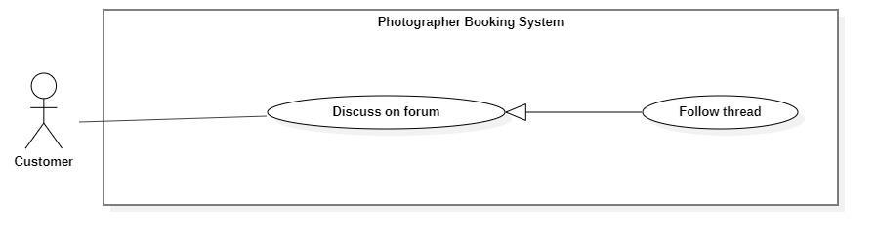

**Figure 8 - <Customer> Overview follow thread**

|  |  |  |  |
| --- | --- | --- | --- |
| UC ID and Name: | **PBS-UC-18 Follow thread** | | |
| Created By: | Tran Thien Thao | Date Created: | 08/10/2020 |
| Primary Actor: | Customer, Photographer, Admin | Secondary Actors: |  |
| Trigger: | The customer choose navigates to the “Diễn đàn” screen after choose thread want to follow | | |
| Description: | The customer follows the thread. | | |
| Preconditions: | - The customer has been authenticated.  - The customer has accessed the Internet. | | |
| Post-conditions: | Success: The customer can follow the thread. | | |
| Normal Flow: | |  |  |  | | --- | --- | --- | | **Step** | **Actor Action** | **System Response** | | 1 | The customer navigates to the “Diễn đàn” screen. | The system shows “Diễn đàn” screen”.  - “Xu hướng gần đây”: main topic.  - “Gần đây nhất”: main topic.  - “Danh mục”: category.  - “Add” icon. | | 2 | The customer click thread wants to follow. | The system shows a thread screen. The following inputs:  - “Chủ đề”: choose a method.  - “Tên chủ đề”: text, required.  - “Bình luận của bạn”: text, required  - “Hình ảnh”: choose the picture  - “V”: button | | 3 | The customer clicks the “Follow” button. | - The system shows a message.  - The system shows thread. | | | |
| Alternative Flows: | N/A | | |
| Exceptions: | N/A | | |
| Priority: | Low | | |
| Frequency of Use: | Sometimes | | |
| Business Rules: | N/A | | |
| Other Information: | N/A | | |
| Assumptions: |  | | |

**Table 8 - <Customer> Follow thread use case specification**

#### c. <Photographer> Overview Use Case

***Figure 14 - <Photographer> Overview use case***

1. ***<Photographer> Get Booking***



***Figure 15 - <Photographer> Get booking***

|  |  |  |  |
| --- | --- | --- | --- |
| UC ID and Name: | **PBS-UC-19 Get booking** | | |
| Created By: | Bo Cong Dat | Date Created: | 08/10/2020 |
| Primary Actor: | Photographer | Secondary Actors: |  |
| Trigger: | Photographers navigates to the “Trang chủ” in Photographer’s application | | |
| Description: | The photographer can view a list of their bookings including all status. | | |
| Preconditions: | - The photographer has been authenticated.  - The photographer has access to the Internet. | | |
| Post-conditions: | Success: the system shows lists of requests on the “Lịch làm việc của tôi” screen. | | |
| Normal Flow: | |  |  |  | | --- | --- | --- | | **Step** | **Actor Action** | **System Response** | | 1 |  | The system shows all requests of customers to the main screen of photographer. | | | |
| Alternative Flows: | N/A | | |
| Exceptions: | N/A | | |
| Priority: | High | | |
| Frequency of Use: | Always | | |
| Business Rules: | N/A | | |
| Other Information: | N/A | | |
| Assumptions: |  | | |

***Table 13 - <Photographer>Get booking use case specification***

1. ***<Photographer> Accept Booking***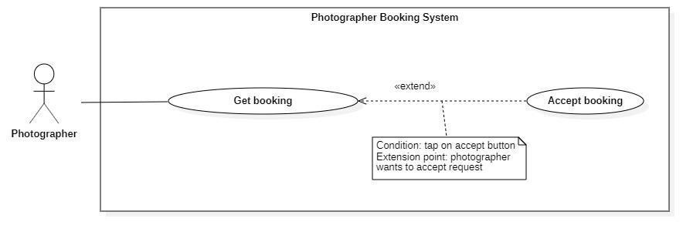

***Figure 16 - <Photographer> Accept Booking***

|  |  |  |  |
| --- | --- | --- | --- |
| UC ID and Name: | **PBS-UC-20 Accept booking** | | |
| Created By: | Bo Cong Dat | Date Created: | 08/10/2020 |
| Primary Actor: | Photographer | Secondary Actors: |  |
| Trigger: | The photographer taps the “Đồng ý” button. | | |
| Description: | The photographer can accept requests from the customer. | | |
| Preconditions: | - The photographer has been authenticated.  - The photographer has access to the Internet.  - The status of request is “Chờ xác nhận”. | | |
| Post-conditions: | Success: the system change status of request is “Sắp diễn ra”. | | |
| Normal Flow: | |  |  |  | | --- | --- | --- | | **Step** | **Actor Action** | **System Response** | | 1 | The photographer taps the “Đồng ý” button when dragging the request to the left. | - The system will change the status of request to “Sắp diễn ra”.  - The system sends notifications to the customer. [Exception 1] | | | |
| Alternative Flows: | |  |  |  | | --- | --- | --- | | Step | Actor Action | System Response | | 1 | The photographer tabs the request “Chờ xác nhận” status. | The system shown detail of request:  - “Trạng thái, thời gian & địa điểm”: text  - “Thông tin khách hàng”: text  - “Thông tin gói dịch vụ”: text  - “Đồng ý”: button  - “Hủy”: button | | 2 | The photographer taps the “Đồng ý” button | - The system will change the status of request to “Sắp diễn ra”.  - The system sends notifications to the customer. [Exception 1] | | | |
| Exceptions: | |  |  |  | | --- | --- | --- | | **No** | **Actor Action** | **System Response** | | 1 | The system sends notifications to the customer. | System shows an error message: “Yêu cầu của bạn đã được xác nhận”. | | | |
| Priority: | High | | |
| Frequency of Use: | Always | | |
| Business Rules: | BR-01 | | |
| Other Information: | N/A | | |
| Assumptions: |  | | |

***Table 14 - <Photographer> Accept Booking use case specification***

1. ***<Photographer> Decline Booking***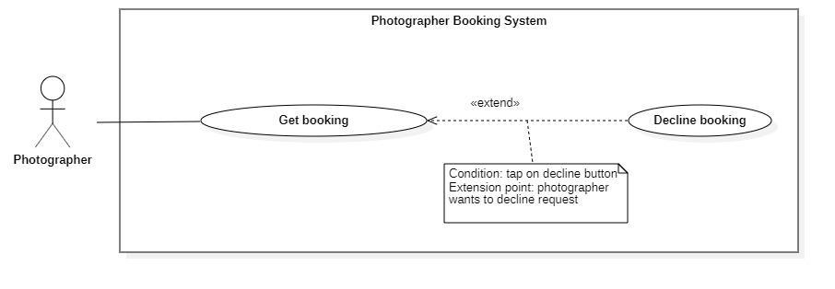

***Figure 17 - <Photographer> Decline Booking***

|  |  |  |  |
| --- | --- | --- | --- |
| UC ID and Name: | **PBS-UC-21 Decline booking** | | |
| Created By: | Bo Cong Dat | Date Created: | 08/10/2020 |
| Primary Actor: | Photographer | Secondary Actors: |  |
| Trigger: | The photographer taps “Hủy” button. | | |
| Description: | The photographer can decline a request from the customer. | | |
| Preconditions: | - The photographer has been authenticated.  - The photographer has access to the Internet.  - The status of request is “Chờ xác nhận”. | | |
| Post-conditions: | Success: the system sends notifications to the customer.F | | |
| Normal Flow: | |  |  |  | | --- | --- | --- | | **Step** | **Actor Action** | **System Response** | | 1 | The photographer taps the “Hủy” button when dragging the request to the left. | - The system sends notification to the customer. [Exception 1] | | | |
| Alternative Flows: | |  |  |  | | --- | --- | --- | | Step | Actor Action | System Response | | 1 | The photographer tabs the request “Chờ xác nhận” status. | The system shown detail of request:  - “Trạng thái, thời gian & địa điểm”: text  - “Thông tin khách hàng”: text  - “Thông tin gói dịch vụ”: text  - “Đồng ý”: button  - “Hủy”: button | | 2 | The photographer taps the “Hủy” button | The system sends notification to the customer. [Exception 1] | | | |
| Exceptions: | |  |  |  | | --- | --- | --- | | **No** | **Actor Action** | **System Response** | | 1 | The system sends notification to the customer. | System shows an error message: “Yêu cầu của bạn đã bị từ chối” | | | |
| Priority: | High | | |
| Frequency of Use: | Sometimes | | |
| Business Rules: | BR-01 | | |
| Other Information: | N/A | | |
| Assumptions: |  | | |

***Table 15 - <Photographer> Cancel Booking Use Case Specification***

1. ***<Photographer> Edit working calendar***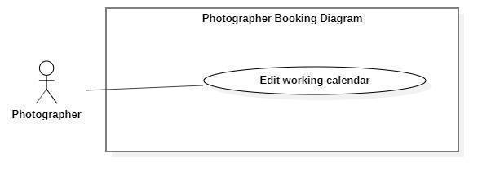

***Figure 18 - <Photographer> Edit working calendar***

|  |  |  |  |
| --- | --- | --- | --- |
| UC ID and Name: | **PBS-UC-22 Edit working calendar** | | |
| Created By: | Bo Cong Dat | Date Created: | 08/10/2020 |
| Primary Actor: | Photographer | Secondary Actors: |  |
| Trigger: | The photographer taps the date in the calendar. | | |
| Description: | The photographer can edit the working calendar. | | |
| Preconditions: | - The photographer has been authenticated.  - The photographer has access to the Internet. | | |
| Post-conditions: | Success: the system updates the calendar of photographers. | | |
| Normal Flow: | |  |  |  | | --- | --- | --- | | **Step** | **Actor Action** | **System Response** | | 1 | The photographer taps day. | The system shows details of day. Photographer can view:  - A list request of customer following start time | | 2 | The photographer taps day in the future and makes an empty request. |  | | | |
| Alternative Flows: | N/A | | |
| Exceptions: | N/A | | |
| Priority: | Medium | | |
| Frequency of Use: | Sometimes | | |
| Business Rules: |  | | |
| Other Information: | N/A | | |
| Assumptions: |  | | |

**Table 16 - <Photographer>Edit Working Calendar Use Case Specification**

1. ***<Photographer> Get customer’s review***

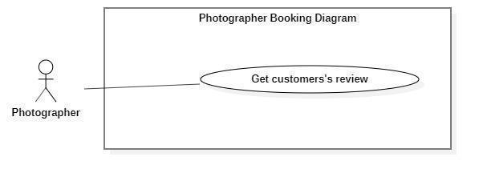

***Figure 19 - <Photographer> Get customer's review***

|  |  |  |  |
| --- | --- | --- | --- |
| UC ID and Name: | **PBS-UC-23 Get customer’s review** | | |
| Created By: | Bo Cong Dat | Date Created: | 08/10/2020 |
| Primary Actor: | Photographer | Secondary Actors: |  |
| Trigger: | The photographer taps “Trang cá nhân” page. | | |
| Description: | The photographer can view the customer's review. | | |
| Preconditions: | - The photographer has been authenticated.  - The photographer has access to the Internet. | | |
| Post-conditions: | Success: the system sends notifications to the customer. | | |
| Normal Flow: | |  |  |  | | --- | --- | --- | | **Step** | **Actor Action** | **System Response** | | 1 | The photographer taps “Trang cá nhân” page. | - The system shows the “Trang cá nhân” page of the photographer. | | | |
| Alternative Flows: | N/A | | |
| Exceptions: | N/A | | |
| Priority: | Medium | | |
| Frequency of Use: | Sometimes | | |
| Business Rules: | BR-08 | | |
| Other Information: | N/A | | |
| Assumptions: |  | | |

***Table 17 - <Photographer> Get Customer’s Review Use Case Specification***

1. ***<Photographer> Add service***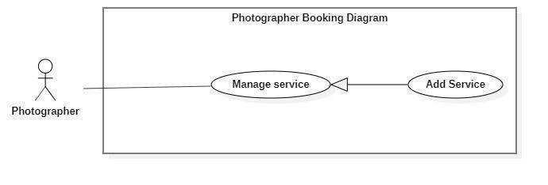

***Figure 20 - <Photographer> Add service***

|  |  |  |  |
| --- | --- | --- | --- |
| UC ID and Name: | **PBS-UC-24 Add Service** | | |
| Created By: | Bo Cong Dat | Date Created: | 08/10/2020 |
| Primary Actor: | Photographer | Secondary Actors: |  |
| Trigger: | The photographer taps add icon on the “Trang cá nhân” screen. | | |
| Description: | The photographer can add service. | | |
| Preconditions: | - The photographer has been authenticated.  - The photographer has access to the Internet. | | |
| Post-conditions: | Success: the photographer adds service to the “Chọn gói dịch vụ bạn muốn” the detail screen. | | |
| Normal Flow: | |  |  |  | | --- | --- | --- | | **Step** | **Actor Action** | **System Response** | | 1 | The photographer taps navigates “Dịch vụ” screen and taps add icon. | The system shows list of services the photographer has added with the following information:  - “Kiểu dịch vụ”: choose a method, required.  - “Tên dịch vụ”: input text, required.  - “Mô tả”: text, required.  - “Giá thành dịch vụ”: input text, required  - “Thời gian tác nghiệp”: input text, required  - “Chi tiết dịch vụ”: input text, required.  - “Phương thức giao hàng”: choose a method.  - “Thêm dịch vụ”: button | | 2 | The photographer taps “Thêm dịch vụ” button | - The system validates inputted data [Exception 1].  - The system sends notifications to the customer. [Exception 2]. | | | |
| Alternative Flows: | N/A | | |
| Exceptions: | |  |  |  | | --- | --- | --- | | **No** | **Actor Action** | **System Response** | | 1 | “Tên dịch vụ”, “Giá thành dịch vụ”, “Chi tiết dịch vụ” is empty | System shows an error message: “Thông tin này bắt buộc” | | 2 | Add service successfully | System shows an error message:  “Thêm dịch vụ thành công”. | | | |
| Priority: | High | | |
| Frequency of Use: | Sometimes | | |
| Business Rules: |  | | |
| Other Information: | N/A | | |
| Assumptions: |  | | |

***Table 18 - <Photographer> Add Service Use Case Specification***

1. ***<Photographer> Edit service***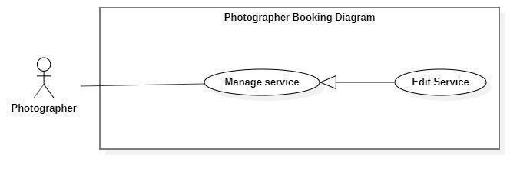

***Figure 21 - <Photographer> Edit Service***

|  |  |  |  |
| --- | --- | --- | --- |
| UC ID and Name: | **PBS-UC-25 Edit service** | | |
| Created By: | Bo Cong Dat | Date Created: | 08/10/2020 |
| Primary Actor: | Photographer | Secondary Actors: |  |
| Trigger: | The photographer taps “Thay đổi” button on “Gói dịch vụ” detail page. | | |
| Description: | The photographer can edit the service available. | | |
| Preconditions: | - The photographer has been authenticated.  - The photographer has access to the Internet.  - The service pack available. | | |
| Post-conditions: | Success: the photographer edit service successfully and update “Các gói dịch vụ bạn muốn” to the detail photographer screen. | | |
| Normal Flow: | |  |  |  | | --- | --- | --- | | **Step** | **Actor Action** | **System Response** | | 1 | The photographer taps “Dịch vụ của tôi”. | The system shows list of services the photographer has view with the following information:  - “Kiểu dịch vụ”: choose a method, required.  - “Tên dịch vụ”: input text, required.  - “Mô tả”: text, required.  - “Giá thành dịch vụ”: input text, required  - “Thời gian tác nghiệp”: input text, required  - “Chi tiết dịch vụ”: input text, required.  - “Phương thức giao hàng”: choose a method.  - “Chỉnh sửa”: button  - “Xóa”: button | | 2 | The photographer taps “Chỉnh sửa” button | The system shows list of services the photographer input with the following information:  - “Kiểu dịch vụ”: choose a method, required.  - “Tên dịch vụ”: input text, required.  - “Mô tả”: text, required.  - “Giá thành dịch vụ”: input text, required  - “Thời gian tác nghiệp”: input text, required  - “Chi tiết dịch vụ”: input text, required.  - “Phương thức giao hàng”: choose a method.  - “Xác nhận”: button  - Hủy”: button | | 3 | The photographer taps “Xác nhận” button | - The system validates inputted data [Exception 1].  - The system sends nontifies to the customer. [Exception 2]. | | | |
| Alternative Flows: | N/A | | |
| Exceptions: | |  |  |  | | --- | --- | --- | | **No** | **Actor Action** | **System Response** | | 2 | “Tên dịch vụ”, “Giá thành dịch vụ”, “Chi tiết dịch vụ” is empty | System shows an error message: “Thông tin này bắt buộc” | | 3 | Edit service successfully | System shows an error message:  “Thay đổi thành công”. | | | |
| Priority: | Medium | | |
| Frequency of Use: | Sometimes | | |
| Business Rules: |  | | |
| Other Information: | N/A | | |
| Assumptions: |  | | |

***Table 19 - <Photographer>Edit service use case specification***

1. ***<Photographer> Remove Service***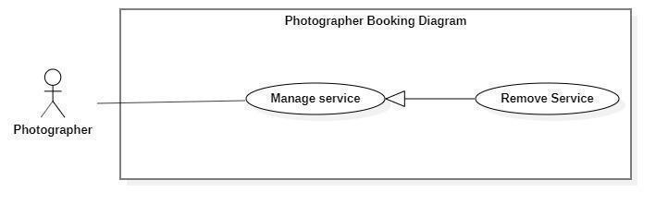

***Figure 22 - <Photographer> Remove Service***

|  |  |  |  |
| --- | --- | --- | --- |
| UC ID and Name: | **PBS-UC-26 Remove service** | | |
| Created By: | Bo Cong Dat | Date Created: | 08/10/2020 |
| Primary Actor: | Photographer | Secondary Actors: |  |
| Trigger: | The photographer taps “Xóa” button in the “Dịch vụ của tôi” screen. | | |
| Description: | The photographer can remove service. | | |
| Preconditions: | - The photographer has been authenticated.  - The photographer has access to the Internet.  - The service pack available. | | |
| Post-conditions: | Success: the photographer removes service successfully and update “Các gói dịch vụ bạn muốn” on the detail screen. | | |
| Normal Flow: | |  |  |  | | --- | --- | --- | | **Step** | **Actor Action** | **System Response** | | 1 | The photographer taps navigate to “Dịch vụ”. | The system shows list of services the photographer has view with the following information:  - “Kiểu dịch vụ”: choose a method, required.  - “Tên dịch vụ”: input text, required.  - “Mô tả”: text, required.  - “Giá thành dịch vụ”: input text, required  - “Thời gian tác nghiệp”: input text, required  - “Chi tiết dịch vụ”: input text, required.  - “Phương thức giao hàng”: choose a method.  - “Xác nhận”: button  - Hủy”: button | | 2 | The photographer taps the “Xóa” button. | The system shows notifications to the photographer. [Exception 1] | | 3 | The photographer taps “Xác nhận” button | The system sends notifications to the customer. [Exception 2]. | | | |
| Alternative Flows: | N/A | | |
| Exceptions: | |  |  |  | | --- | --- | --- | | **No** | **Actor Action** | **System Response** | | 1 | The photographer taps the “Xóa” button. | System shows an error message: “Bạn có muốn xóa dịch vụ này?” | | 2 | Remove service successfully | System shows an error message:  “Xóa dịch vụ thành công”. | | | |
| Priority: | Medium | | |
| Frequency of Use: | Sometimes | | |
| Business Rules: |  | | |
| Other Information: | N/A | | |
| Assumptions: |  | | |

1. ***<Photographer>Add album***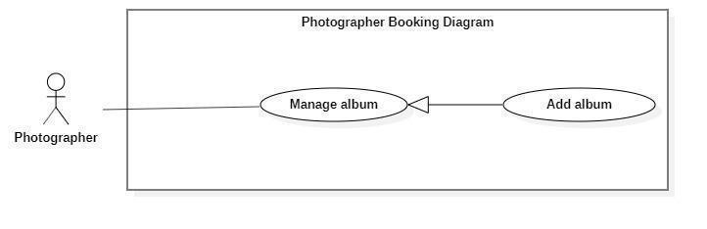

***Figure 23 - <Photographer> Add Album***

|  |  |  |  |
| --- | --- | --- | --- |
| UC ID and Name: | **PBS-UC-27 Add Album** | | |
| Created By: | Bo Cong Dat | Date Created: | 08/10/2020 |
| Primary Actor: | Photographer | Secondary Actors: |  |
| Trigger: | The photographer taps the add album icon on the “Album” screen. | | |
| Description: | The photographer can add albums. | | |
| Preconditions: | - The photographer has been authenticated.  - The photographer has access to the Internet. | | |
| Post-conditions: | Success: the photographer adds the album successfully and update “Các album của photographer” on the detail screen. | | |
| Normal Flow: | |  |  |  | | --- | --- | --- | | **Step** | **Actor Action** | **System Response** | | 1 | The photographer taps the “Album” screen and taps the added album icon. | The system shows list of albums available the photographer has added photo with the following information:  - “Ngày tạo”: choose date, required.  - “Mô tả”: text, required.  - “Tên album”: input text, required.  - “Hình ảnh”: choose the device.  - “Category”: choose method, required  - “Địa điểm”: input text, required.  - “Thêm album”: button | | 2 | The photographer taps “Thêm album” button | - The system validates inputted data [Exception 1].  - The system sends notifications to the customer. [Exception 2]. | | | |
| Alternative Flows: | N/A | | |
| Exceptions: | |  |  |  | | --- | --- | --- | | **No** | **Actor Action** | **System Response** | | 1 | “Tên album” and “Hình ảnh”, “thể loại” is empty | System shows an error message: “Thông tin này bắt buộc” | | 2 | Add album successfully | System shows an error message:  “Thêm album thành công”. | | | |
| Priority: | Medium | | |
| Frequency of Use: | Sometimes | | |
| Business Rules: |  | | |
| Other Information: | N/A | | |
| Assumptions: | . | | |

***Table 20 - <Photographer> Add album use case specification***

1. ***<Photographer> Edit album***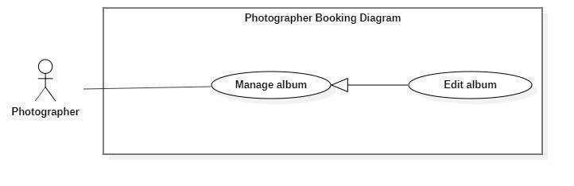

***Figure 24 - <Photographer> Edit Album***

|  |  |  |  |
| --- | --- | --- | --- |
| UC ID and Name: | **PBS-UC-28 Edit Album** | | |
| Created By: | Bo Cong Dat | Date Created: | 08/10/2020 |
| Primary Actor: | Photographer | Secondary Actors: |  |
| Trigger: | The photographer taps “Album” detail and taps “Chỉnh sửa” button. | | |
| Description: | The photographer can edit the album of them. | | |
| Preconditions: | - The photographer has been authenticated.  - The photographer has access to the Internet.  - The album available. | | |
| Post-conditions: | Success: the photographer edited the album successfully and update “Các album của photographer” on the detail screen. | | |
| Normal Flow: | |  |  |  | | --- | --- | --- | | **Step** | **Actor Action** | **System Response** | | 1 | The photographer taps “Album”. | The system shows a list of photos available. The photographer has view photo with the following information:  - “Ngày tạo”: choose date, required.  - “Mô tả”: text, required.  - “Tên album”: input text, required.  - “Hình ảnh”: choose the device.  - “Category”: choose method, required  - “Địa điểm”: input text, required.  - “Xóa”: button  - “Chỉnh sửa”: button | | 2 | The photographer taps “Chỉnh sửa” button. | The system shows a detailed photo screen. The photographer has edit album with the following information:  - “Ngày tạo”: choose date, requid.  - “Mô tả”: text, requid.  - “Tên album”: input text, required.  - “Hình ảnh”: choose the device.  - “Category”: choose method, required  - “Địa điểm”: input text, required.  - “Xác nhận”: button  -”Hủy”: button | | 3 | The photographer taps “Xác nhận” button | - The system validates inputted data [Exception 1].  - The system sends notifications to the customer. [Exception 2]. | | | |
| Alternative Flows: | N/A | | |
| Exceptions: | |  |  |  | | --- | --- | --- | | **No** | **Actor Action** | **System Response** | | 1 | “Tên album” and “Hình ảnh”, “thể loại” is empty | System shows an error message: “Thông tin này bắt buộc” | | 2 | The photographer taps the “Xác nhận” button. | System shows an error message:  “Thay đổi album thành công”. | | | |
| Priority: | Medium | | |
| Frequency of Use: | Sometimes | | |
| Business Rules: |  | | |
| Other Information: | N/A | | |
| Assumptions: |  | | |

***Table 21 - <Photographer> Edit Album Use Case Specification***

1. ***<Photographer> Remove album***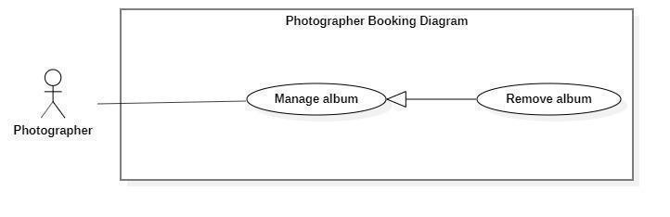

***Figure 25 - <Photographer> Remove Album***

|  |  |  |  |
| --- | --- | --- | --- |
| UC ID and Name: | **PBS-UC-29 Remove Album** | | |
| Created By: | Bo Cong Dat | Date Created: | 08/10/2020 |
| Primary Actor: | Photographer | Secondary Actors: |  |
| Trigger: | The photographer taps the “Xóa” button. | | |
| Description: | The photographer can remove the album. | | |
| Preconditions: | - The photographer has been authenticated.  - The photographer has access to the Internet.  - The album available. | | |
| Post-conditions: | Success: the photographer removed the album successfully and update “Các album của photographer” on the detail screen. | | |
| Normal Flow: | |  |  |  | | --- | --- | --- | | **Step** | **Actor Action** | **System Response** | | 1 | The photographer taps the “Xóa” button. | The system shows notifications to the photographer. [Exception 1] | | 2 | The photographer taps the “Xác nhận” button. | The system shows notifications to the photographer. [Exception 2]. | | | |
| Alternative Flows: | N/A | | |
| Exceptions: | |  |  |  | | --- | --- | --- | | **No** | **Actor Action** | **System Response** | | 1 | The photographer taps the “Xóa” button. | System shows an error message: “Bạn có muốn xóa album này?” | | 2 | The photographer taps the “Xác nhận” button. | System shows an error message:  “Xóa album thành công”. | | | |
| Priority: | Medium | | |
| Frequency of Use: | Sometimes | | |
| Business Rules: |  | | |
| Other Information: | N/A | | |
| Assumptions: |  | | |

#### d. <Authenticated User> Overview Use Case

***Figure 26 - <Authenticated User> Overview Use Case***

1. ***<Authenticated User> Get profile***

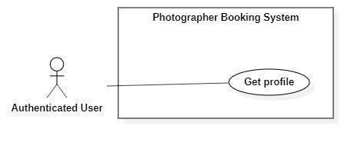

***Figure 27 - <Authenticated User> Get profile***

|  |  |  |  |
| --- | --- | --- | --- |
| UC ID and Name: | **PBS-UC-30 Get profile** | | |
| Created By: | Tran Thien Thao | Date Created: | 08/10/2020 |
| Primary Actor: | Authenticated User | Secondary Actors: |  |
| Trigger: | The Authenticated User navigates to “Cài đặt” and taps the “Thông tin cá nhân” screen to view the profile. | | |
| Description: | The authenticated user can view their profile. | | |
| Preconditions: | The authenticated user has accessed the Internet. | | |
| Post-conditions: | Success: The Authenticated User can view his/her profile successfully. | | |
| Normal Flow: | |  |  |  | | --- | --- | --- | | **Step** | **Actor Action** | **System Response** | | 1 | The Authenticated User navigates to the “Cài đặt” and taps the “Thông tin cá nhân” screen to view the profile. | The system shows “Thông tin cá nhân” screen with the following information:  - “Avatar”: image.  - “Họ và tên”: text input, editable  - “Địa chỉ”: text input, editable  - “Số điện thoại”: phone number input  - “Email”: text input, required.  - “Cập nhật” button | | | |
| Alternative Flows: | N/A | | |
| Exceptions: | N/A | | |
| Priority: | Medium | | |
| Frequency of Use: | Sometimes | | |
| Business Rules: | N/A | | |
| Other Information: | N/A | | |
| Assumptions: |  | | |

***Table 22 - <Authenticated User> Get profile use case specification***

1. ***<Authenticated User> Edit profile***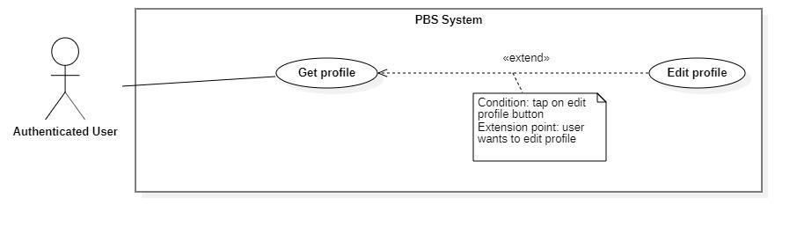

***Figure 28 - <Authenticated User> Edit profile***

|  |  |  |  |
| --- | --- | --- | --- |
| UC ID and Name: | **PBS-UC-31 Edit profile** | | |
| Created By: | Tran Thien Thao | Date Created: | 08/10/2020 |
| Primary Actor: | Authenticated User | Secondary Actors: |  |
| Trigger: | The Authenticated User taps “Cập nhật” of “Thông tin cá nhân” screen to view profile. | | |
| Description: | The authenticated user can update their profile. | | |
| Preconditions: | The authenticated user has accessed the Internet. | | |
| Post-conditions: | Success: The Authenticated User can update his/her profile successfully. | | |
| Normal Flow: | |  |  |  | | --- | --- | --- | | **Step** | **Actor Action** | **System Response** | | 1 | The Authenticated User taps the“Thông tin cá nhân” screen to view the profile. | The system shows “Thông tin cá nhân” screen and view with the following information:  - “Avatar”: image  - “Họ và tên”: text input, editable  - “Địa chỉ: text input, editable  - “Số điện thoại”: phone number input.  - “Email”: text input, required  - “Cập nhật” button: is used to update information. | | 2 | The Authenticated User updates information and clicks “Cập nhật” to confirm | The system shows “Thông tin cá nhân” screen and view with the following information:  - “Avatar”: image  - “Họ và tên”: text input, editable  - “Địa chỉ: text input, editable  - “Số điện thoại”: phone number input.  - “Xác nhận” button  - “Hủy”: button | | 3 | The Authenticated User updates information and clicks “Xác nhận” to confirm | The system validates inputted data  The system updates the profile and shows message  [Exception 1, 2] | | | |
| Alternative Flows: | N/A | | |
| Exceptions: | |  |  |  | | --- | --- | --- | | **No** | **Actor Action** | **System Response** | | 1 | “Họ và tên”, “địa chỉ”, “Số điện thoại” is empty | System shows an error message: “Thông tin này bắt buộc”. | | 2 | Update successfully | System shows an error message: “Cập nhật thông tin thành công”. | | | |
| Priority: | Medium | | |
| Frequency of Use: | Sometimes | | |
| Business Rules: |  | | |
| Other Information: | N/A | | |
| Assumptions: |  | | |

***Table 23 - <Authenticated User> Edit profile use case specification***

1. ***<Authenticated User> Change password***

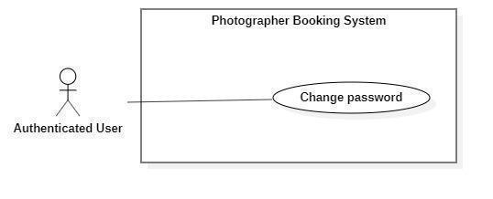

***Figure 29 - <Authenticated User> Change password***

|  |  |  |  |
| --- | --- | --- | --- |
| UC ID and Name: | **PBS-UC-32 Change password** | | |
| Created By: | Tran Thien Thao | Date Created: | 08/10/2020 |
| Primary Actor: | Authenticated User | Secondary Actors: |  |
| Trigger: | The Authenticated User navigates to “Cài đặt” screen and taps the “Thay đổi mật khẩu” to change password. | | |
| Description: | The authenticated user can change their password. | | |
| Preconditions: | The authenticated user has accessed the Internet. | | |
| Post-conditions: | Success: The Authenticated User can change password successfully and logout the system. | | |
| Normal Flow: | |  |  |  | | --- | --- | --- | | **Step** | **Actor Action** | **System Response** | | 1 | The Authenticated User navigates to “Cài đặt” screen and taps the “Thay đổi mật khẩu” | The system shows “Đổi mật khẩu” screen with the following inputs:  - “Mật khẩu hiện tại”: current password, password input, required  - “Mật khẩu mới”: new password, password input, required  - “Xác nhận mật khẩu mới”: confirm new password, password input, required  - “xác nhận” button.  - “Hủy”: button | | 2 | The Authenticated User inputs information and taps “Xác nhận” to confirm. | The system validates inputted data  [Exception 1, 2]  The system updates the profile and shows message  [Exception 3] | | | |
| Alternative Flows: | N/A | | |
| Exceptions: | |  |  |  | | --- | --- | --- | | **No** | **Actor Action** | **System Response** | | 1 | “Mật khẩu hiện tại”, “Mật khẩu mới”, “xác nhận mật khẩu mới” is empty | System shows an error message: “Thông tin này bắt buộc”. | | 2 | New password and confirm password do not match. | System shows an error message: “Mật khẩu nhập lại chưa chính xác” | | 3 | Current password is invalid | System shows an error message: “Mật khẩu hiện tại chưa chính xác” | | | |
| Priority: | Medium | | |
| Frequency of Use: | Sometimes | | |
| Business Rules: |  | | |
| Other Information: | N/A | | |
| Assumptions: |  | | |

**Table 24 - <Authenticated User> Change Password Use Case specification**

1. ***<Authenticated User> Logout***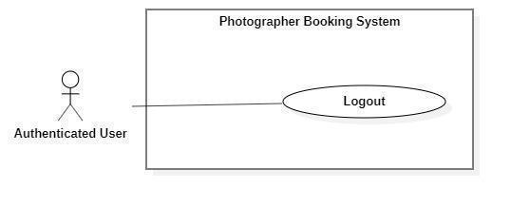

***Figure 30 - <Authenticated User> Logout***

|  |  |  |  |
| --- | --- | --- | --- |
| UC ID and Name: | **PBS-UC-33 Logout** | | |
| Created By: | Tran Thien Thao | Date Created: | 08/10/2020 |
| Primary Actor: | Authenticated User | Secondary Actors: |  |
| Trigger: | The Authenticated User navigates to “Cài đặt” screen and taps the “Đăng xuất” to log out. | | |
| Description: | The system allows the Authenticated User to log out | | |
| Preconditions: | The authenticated user has accessed the Internet. | | |
| Post-conditions: | Success: The Authenticated User can log out successfully. | | |
| Normal Flow: | |  |  |  | | --- | --- | --- | | **Step** | **Actor Action** | **System Response** | | 1 | The Authenticated User navigates to “Cài đặt” screen to log out | The system deletes the login session and navigates the back to “Đăng nhập” screen. | | | |
| Alternative Flows: | N/A | | |
| Exceptions: | N/A | | |
| Priority: | Medium | | |
| Frequency of Use: | Always | | |
| Business Rules: | N/A | | |
| Other Information: | N/A | | |
| Assumptions: |  | | |

***Table 25 - <Authenticated User> Logout use case specification***

#### e. <Admin> Overview Use Case

***Figure 31 - <Admin> Overview Use Case***

1. ***<Admin> Get user’s activity***

***Figure 32 - <Admin> Get user's activity***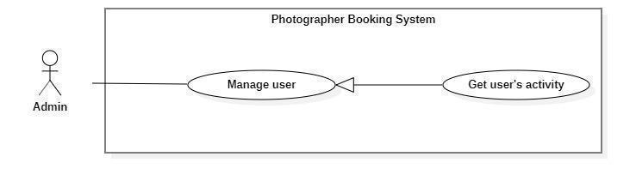

|  |  |  |  |
| --- | --- | --- | --- |
| UC ID and Name: | **PBS-UC-34 Get user’s activity** | | |
| Created By: | Dao Sy Trung Kien | Date Created: | 08/10/2020 |
| Primary Actor: | Admin | Secondary Actors: |  |
| Trigger: | The admin taps navigate to “Hoạt động” screen. | | |
| Description: | The admin can view a list of the user's activity. | | |
| Preconditions: | - User must be an Admin.  - User has logged into the website. | | |
| Post-conditions: | Success: The admin can view a table and a list of the user's activity successfully. | | |
| Normal Flow: | |  |  |  | | --- | --- | --- | | **Step** | **Actor Action** | **System Response** | | 1 | The admin taps navigate to the “Hoạt động” screen. | The system showed a table a list of the user's activity. | | | |
| Alternative Flows: | N/A | | |
| Exceptions: | N/A | | |
| Priority: | Medium | | |
| Frequency of Use: | Always | | |
| Business Rules: | BR-10, BR-11 | | |
| Other Information: | N/A | | |
| Assumptions: |  | | |

***Table 26 - <Admin> Get user's activity use case specification***

1. ***<Admin> Block user***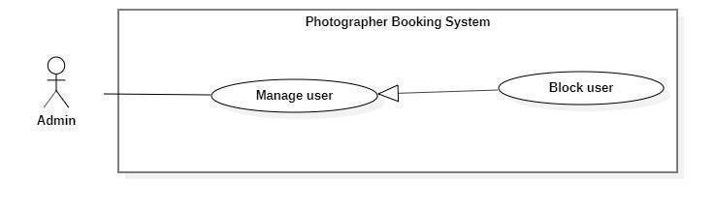

***Figure 33 - <Admin> Block user***

|  |  |  |  |
| --- | --- | --- | --- |
| UC ID and Name: | **PBS-UC-35 Block user** | | |
| Created By: | Dao Sy Trung Kien | Date Created: | 08/10/2020 |
| Primary Actor: | Admin | Secondary Actors: |  |
| Trigger: | The admin tabs “Khóa” button on the “Danh sách người dùng” screen. | | |
| Description: | The admin can block users if the user violates business rules. | | |
| Preconditions: | - User must be an Admin.  - User has logged into the website. | | |
| Post-conditions: | Success: The admin can block users successfully. | | |
| Normal Flow: | |  |  |  | | --- | --- | --- | | **Step** | **Actor Action** | **System Response** | | 1 | The admin tabs “Khóa” button on the “Danh sách người dùng” screen. | The system shows notifications to the admin. [Exception 1]. | | 2 | The admin taps the “Xác nhận” button. | The system shows notifications to the admin. [Exception 2] | | 3 |  | The system sends notifications to the user. [Exception 3]. | | | |
| Alternative Flows: | N/A | | |
| Exceptions: | |  |  |  | | --- | --- | --- | | **No** | **Actor Action** | **System Response** | | 1 | The system shows notifications to the admin. | System shows an error message: “Bạn có muốn khóa người dùng này?”. | | 2 | The admin taps the “Xác nhận” button. | System shows an error message: “Người dùng đã được khóa thành công”. | | 3 | The system sends notifications to the user. | System shows an error message: “Tài khoản của bạn đã bị vi phạm. Vui lòng liên hệ với quản trị viên”. | | | |
| Priority: | High | | |
| Frequency of Use: | Sometimes | | |
| Business Rules: | BR-09 | | |
| Other Information: | N/A | | |
| Assumptions: |  | | |

1. ***<Admin> Unblock user***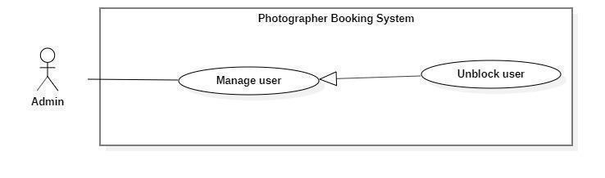

***Figure 34 - <Admin> Unblock user***

|  |  |  |  |
| --- | --- | --- | --- |
| UC ID and Name: | **PBS-UC-36 Unblock user** | | |
| Created By: | Dao Sy Trung Kien | Date Created: | 08/10/2020 |
| Primary Actor: | Admin | Secondary Actors: |  |
| Trigger: | The admin tabs “Mở khóa” button on the “Danh sách người dùng” screen. | | |
| Description: | The admin can unblock users. | | |
| Preconditions: | - User must be an Admin.  - User has logged into the website.  - The user locked. | | |
| Post-conditions: | Success: The admin can unblock users successfully. | | |
| Normal Flow: | |  |  |  | | --- | --- | --- | | **Step** | **Actor Action** | **System Response** | | 1 | The admin tabs “Mở khóa” button on the “Danh sách người dùng” screen. | The system shows notifications to the admin. [Exception 1] | | 2 | The admin taps the “Xác nhận” button. | The system shows notifications to the admin. [Exception 3] | | | |
| Alternative Flows: | N/A | | |
| Exceptions: | |  |  |  | | --- | --- | --- | | **No** | **Actor Action** | **System Response** | | 1 | The system shows notifications to the admin. | System shows an error message: “Bạn có muốn mở khóa người dùng này?”. | | 2 | The admin taps the “Xác nhận” button. | System shows an error message: “Người dùng đã được mở khóa thành công”. | | | |
| Priority: | High | | |
| Frequency of Use: | Sometimes | | |
| Business Rules: | BR-09 | | |
| Other Information: | N/A | | |
| Assumptions: |  | | |

***Table 27 - <Admin> Unblock user use case specification***

1. ***<Admin> Get customer’s review***

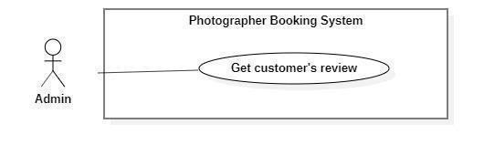

***Figure 35 - <Admin> Get customer's review***

|  |  |  |  |
| --- | --- | --- | --- |
| UC ID and Name: | **PBS-UC-37 Get customer’s review** | | |
| Created By: | Dao Sy Trung Kien | Date Created: | 08/10/2020 |
| Primary Actor: | Admin | Secondary Actors: |  |
| Trigger: | The admin taps the “Trang cá nhân” page of the photographer. | | |
| Description: | The admin can view customer’s review. | | |
| Preconditions: | - User must be an Admin.  - User has logged into the website. | | |
| Post-conditions: | Success: the admin views the customer’s review. | | |
| Normal Flow: | |  |  |  | | --- | --- | --- | | **Step** | **Actor Action** | **System Response** | | 1 | The admin taps “Trang cá nhân” page. | - The system shows the “Trang cá nhân” page of the photographer. [Exception 1] | | | |
| Alternative Flows: | N/A | | |
| Exceptions: | N/A | | |
| Priority: | Medium | | |
| Frequency of Use: | Sometimes | | |
| Business Rules: | BR-23, BR-24 | | |
| Other Information: | N/A | | |
| Assumptions: |  | | |

***Table 28 - <Admin> Get customer's review use case specification***

1. ***<Admin> Add shooting category***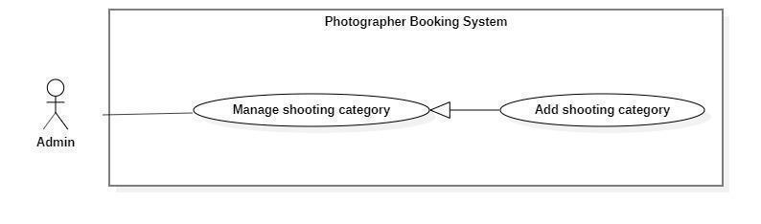

***Figure 36 - <Admin> Add shooting category***

|  |  |  |  |
| --- | --- | --- | --- |
| UC ID and Name: | **PBS-UC-38 Add shooting category** | | |
| Created By: | Dao Sy Trung Kien | Date Created: | 08/10/2020 |
| Primary Actor: | Admin | Secondary Actors: |  |
| Trigger: | The admin taps “Thêm thể loại” button. | | |
| Description: | The admin can add a shooting category. | | |
| Preconditions: | - User must be an Admin.  - User has logged into the website. | | |
| Post-conditions: | Success: The admin can add shooting successfully and update “Trang chủ” of customer’s application. | | |
| Normal Flow: | |  |  |  | | --- | --- | --- | | **Step** | **Actor Action** | **System Response** | | 1 | The admin taps “Thêm thể loại” button. | The system shown “Thêm thể loại chụp ảnh” page. The admin input following:  - “Tên thể loại”: input text, required.  - “Xác nhận”: button.  - “Hủy”: button | | 2 | The photographer taps the “Xác nhận” button. | - The system validates inputted data  [Exception 1, 2]  - The system shows notifications to the photographer. [Exception 3]. | | | |
| Alternative Flows: | N/A | | |
| Exceptions: | |  |  |  | | --- | --- | --- | | **No** | **Actor Action** | **System Response** | | 1 | “Tên thể loại” is empty | System shows an error message: “Thông tin này bắt buộc” | | 2 | “Tên thể loại” is duplicate | System shows an error message: “Thể loại này đã tồn tại” | | 3 | The photographer taps the “Xác nhận” button. | System shows an error message:  “Thêm thể loại thành công”. | | | |
| Priority: | Medium | | |
| Frequency of Use: | Sometimes | | |
| Business Rules: | BR-12 | | |
| Other Information: | N/A | | |
| Assumptions: |  | | |

***Table 29 - <Admin> Add shooting category use case specification***

1. ***<Admin> Edit shooting category***

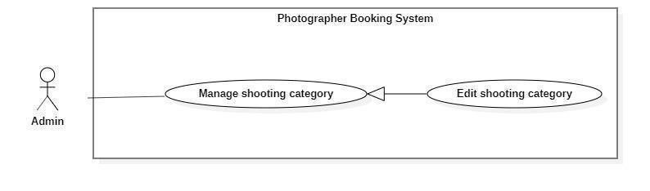

***Figure 37 - <Admin> Edit shooting category***

|  |  |  |  |
| --- | --- | --- | --- |
| UC ID and Name: | **PBS-UC-39 Edit shooting category** | | |
| Created By: | Dao Sy Trung Kien | Date Created: | 08/10/2020 |
| Primary Actor: | Admin | Secondary Actors: |  |
| Trigger: | The admin tabs “Chỉnh sửa” button on the “Thể loại” detail screen. | | |
| Description: | The admin can edit the shooting category. | | |
| Preconditions: | - User must be an Admin.  - User has logged into the website.  - The category available. | | |
| Post-conditions: | Success: The admin can edit shooting successfully and update “Trang chủ” of customer’s application. | | |
| Normal Flow: | |  |  |  | | --- | --- | --- | | **Step** | **Actor Action** | **System Response** | | 1 | The admin taps “Thể loại” to the view detail. | The system showed a list of category pages.  - “Tên thể loại”: text  - “Xóa”: button  - “Chỉnh sửa”: button. | | 2 | The photographer taps the “Cập nhật” button. | The system shown “Thể loại” detail screen. The admin input following:  - “Tên thể loại”: input text, required.  - “Xác nhận”: button. | | 3 | The photographer taps the “Xác nhận” button. | - The system validates inputted data [Exception 1, 2]  - The system shows notifications to the photographer. [Exception 3]. | | | |
| Alternative Flows: | N/A | | |
| Exceptions: | |  |  |  | | --- | --- | --- | | **No** | **Actor Action** | **System Response** | | 1 | “Tên thể loại” is empty | System shows an error message: “Thông tin này bắt buộc” | | 2 | “Tên thể loại” is duplicate | System shows an error message: “Thể loại này đã tồn tại” | | 3 | The photographer taps the “Xác nhận” button. | System shows an error message:  “Thay đổi thể loại thành công”. | | | |
| Priority: | Medium | | |
| Frequency of Use: | Sometimes | | |
| Business Rules: | BR-13 | | |
| Other Information: | N/A | | |
| Assumptions: |  | | |

***Table 30 - <Admin> Edit shooting category use case specification***

1. ***<Admin> Remove shooting category***

***Figure 38 - <Admin> Remove shooting category***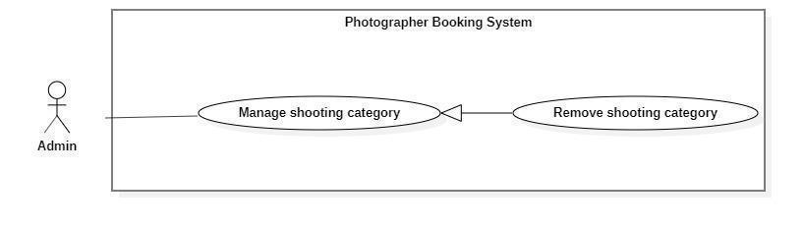

|  |  |  |  |
| --- | --- | --- | --- |
| UC ID and Name: | **PBS-UC-40 Edit shooting category** | | |
| Created By: | Dao Sy Trung Kien | Date Created: | 08/10/2020 |
| Primary Actor: | Admin | Secondary Actors: |  |
| Trigger: | The admin tabs “Xóa” button on the “Danh sách thể loại” screen. | | |
| Description: | The admin can remove the shooting category. | | |
| Preconditions: | - User must be an Admin.  - User has logged into the website.  - The category available. | | |
| Post-conditions: | Success: The admin can remove shooting successfully and update “Trang chủ” of customer’s application. | | |
| Normal Flow: | |  |  |  | | --- | --- | --- | | **Step** | **Actor Action** | **System Response** | | 1 | The admin taps “Thể loại” to the view detail. | The system showed a list of category pages.  - “Tên thể loại”: text  - “Xóa”: button  - “Chỉnh sửa”: button. | | 2 | The admin taps “Xóa” button | The system shows notifications to the photographer. [Exception 1] | | 3 | The photographer taps the “Xác nhận” button. | - The system shows notifications to the photographer. [Exception 2]. | | | |
| Alternative Flows: | N/A | | |
| Exceptions: | |  |  |  | | --- | --- | --- | | **No** | **Actor Action** | **System Response** | | 1 | The admin taps remove the category icon. | System shows an error message: “Bạn có muốn xóa thể loại này ra khỏi thư mục?” | | 2 | The photographer taps the “Xác nhận” button. | System shows an error message:  “Xóa thể loại thành công”. | | | |
| Priority: | Medium | | |
| Frequency of Use: | Sometimes | | |
| Business Rules: | BR-14 | | |
| Other Information: | N/A | | |
| Assumptions: |  | | |

**Table 31 - <Admin> Remove shooting category use case specification**

1. ***<Admin> Manage delivery method***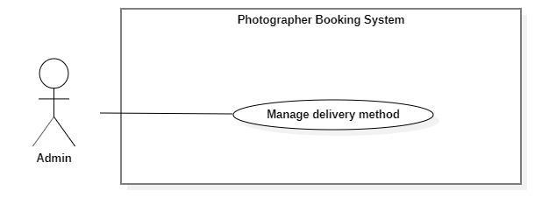

**Figure 9 - <Admin> Overview manage delivery method**

|  |  |  |  |
| --- | --- | --- | --- |
| UC ID and Name: | **PBS-UC-41 Manage delivery method** | | |
| Created By: | Dao Sy Trung Kien | Date Created: | 08/10/2020 |
| Primary Actor: | Admin | Secondary Actors: |  |
| Trigger: | The admin taps “Thêm phương thức giao hàng” button. | | |
| Description: | The admin can add a shooting category. | | |
| Preconditions: | - User must be an Admin.  - User has logged into the website. | | |
| Post-conditions: | Success: The admin can add a delivery method successfully and update “Phương thức giao hàng” of photographer’s application. | | |
| Normal Flow: | |  |  |  | | --- | --- | --- | | **Step** | **Actor Action** | **System Response** | | 1 | The admin taps “Thêm thể loại” button. | The system shown “Phương thức giao hàng” page. The admin input following:  - “Phương thức giao hàng”: input text, required.  - “Xác nhận”: button.  - “Hủy”: button | | 2 | The photographer taps the “Xác nhận” button. | - The system validates inputted data  [Exception 1, 2]  - The system shows notifications to the photographer. [Exception 3]. | | | |
| Alternative Flows: | N/A | | |
| Exceptions: | |  |  |  | | --- | --- | --- | | **No** | **Actor Action** | **System Response** | | 1 | “Phương thức giao hàng” is empty | System shows an error message: “Thông tin này bắt buộc” | | 2 | “Phương thức giao hàng” is duplicate | System shows an error message: “Thể loại này đã tồn tại” | | 3 | The photographer taps the “Xác nhận” button. | System shows an error message:  “Thêm thể loại thành công”. | | | |
| Priority: | Medium | | |
| Frequency of Use: | Sometimes | | |
| Business Rules: | N/A | | |
| Other Information: | N/A | | |
| Assumptions: |  | | |

**Table 9 - <Admin> Manage delivery method use case specification**

1. ***<Admin> Manage variables***

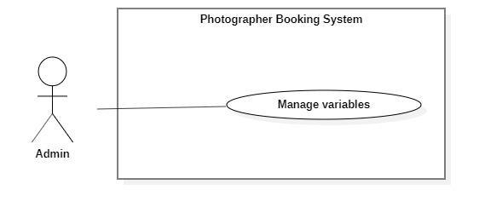

**Figure 10 - <Admin> Overview manage variables**

|  |  |  |  |
| --- | --- | --- | --- |
| UC ID and Name: | **PBS-UC-42 Manage variables** | | |
| Created By: | Dao Sy Trung Kien | Date Created: | 08/10/2020 |
| Primary Actor: | Admin | Secondary Actors: |  |
| Trigger: | The admin taps “Variables” button. | | |
| Description: | The admin can manage variables. | | |
| Preconditions: | - User must be an Admin.  - User has logged into the website. | | |
| Post-conditions: | Success: The admin can manage variables. | | |
| Normal Flow: | |  |  |  | | --- | --- | --- | | **Step** | **Actor Action** | **System Response** | | 1 | The admin taps the “Variables” button. | The system shown “Variables” page. | | | |
| Alternative Flows: | N/A | | |
| Exceptions: | N/A | | |
| Priority: | Low | | |
| Frequency of Use: | Sometimes | | |
| Business Rules: | N/A | | |
| Other Information: | N/A | | |
| Assumptions: |  | | |

**Table 10 - <Admin> Manage variables use case specification**

#### f. <System handler> Overview use case

1. **<System handler> Make booking notification**

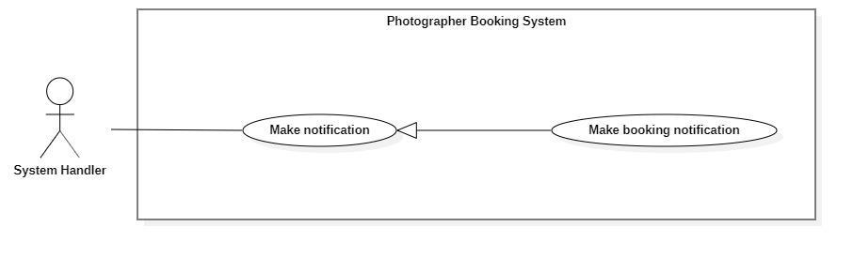

|  |  |  |  |
| --- | --- | --- | --- |
| UC ID and Name: | **PBS-UC-43 Make booking notification** | | |
| Created By: | Dao Sy Trung Kien | Date Created: | 08/10/2020 |
| Primary Actor: | System handler | Secondary Actors: |  |
| Trigger: | The customer sends a request to the photographer.  The photographers respond to requests for customers. | | |
| Description: | The customer receives notices of his request sent to the photographer and also is the photographer. | | |
| Preconditions: | - The customer sends a request successfully. | | |
| Post-conditions: | Success: The system make booking notification and sends to the customer | | |
| Normal Flow: | |  |  |  | | --- | --- | --- | | **Step** | **Actor Action** | **System Response** | | 1 | System handler retrieves make booking notifications. | The system stores requests and makes notification information to return to the system's handler. | | 2 | System handler retrieves notification information and sends it to customers. |  | | | |
| Alternative Flows: | N/A | | |
| Exceptions: | |  |  |  | | --- | --- | --- | | No | Actor Action | System Response | | 1 | Make notification process encountered an internal error. | Error details will be tracked in the log file. System outputs error messages and sends them to user. | | | |
| Priority: | Low | | |
| Frequency of Use: | Sometimes | | |
| Business Rules: | N/A | | |
| Other Information: | N/A | | |
| Assumptions: |  | | |

## 3. Functional Requirements

### 3.1 System Functional Overview

#### a. Screen Flow

1. **Customer’s screen flow**

***Figure 39 - Customer's Screen Flow***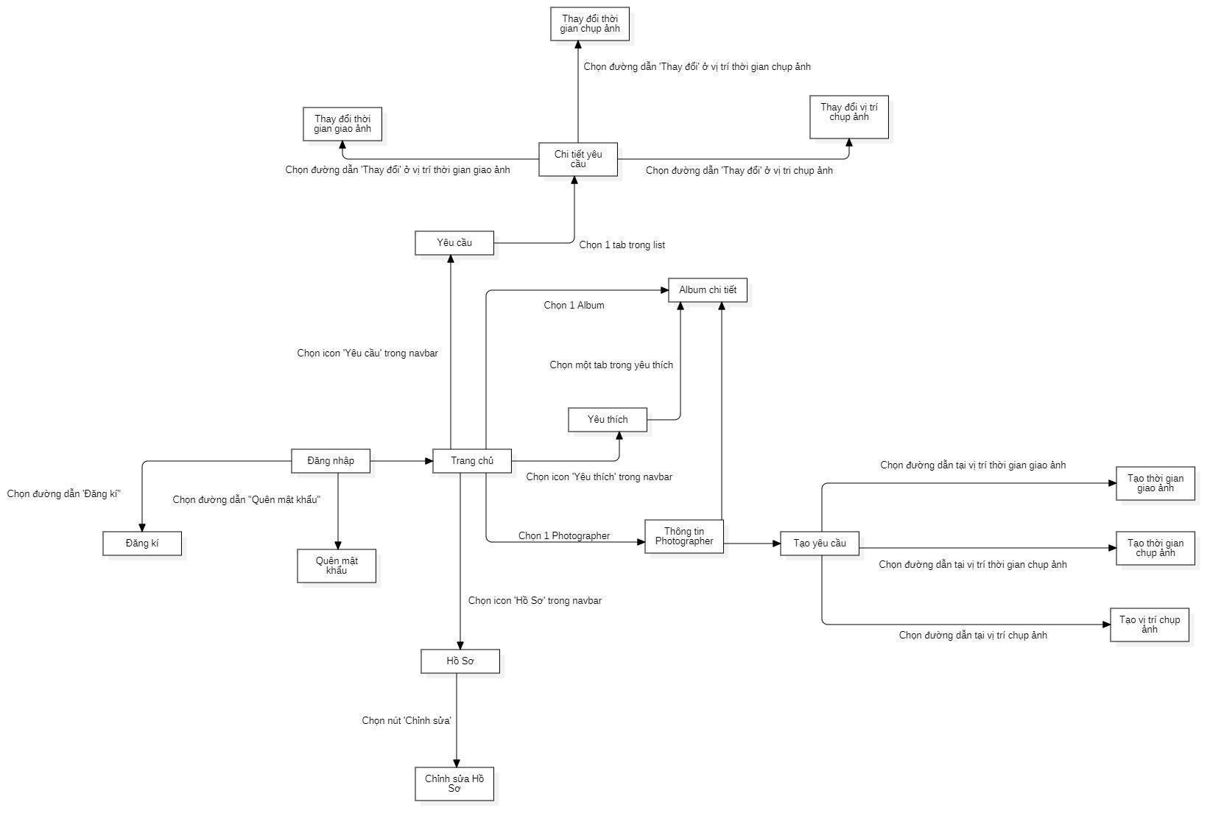

1. **Photographer’s screen flow**

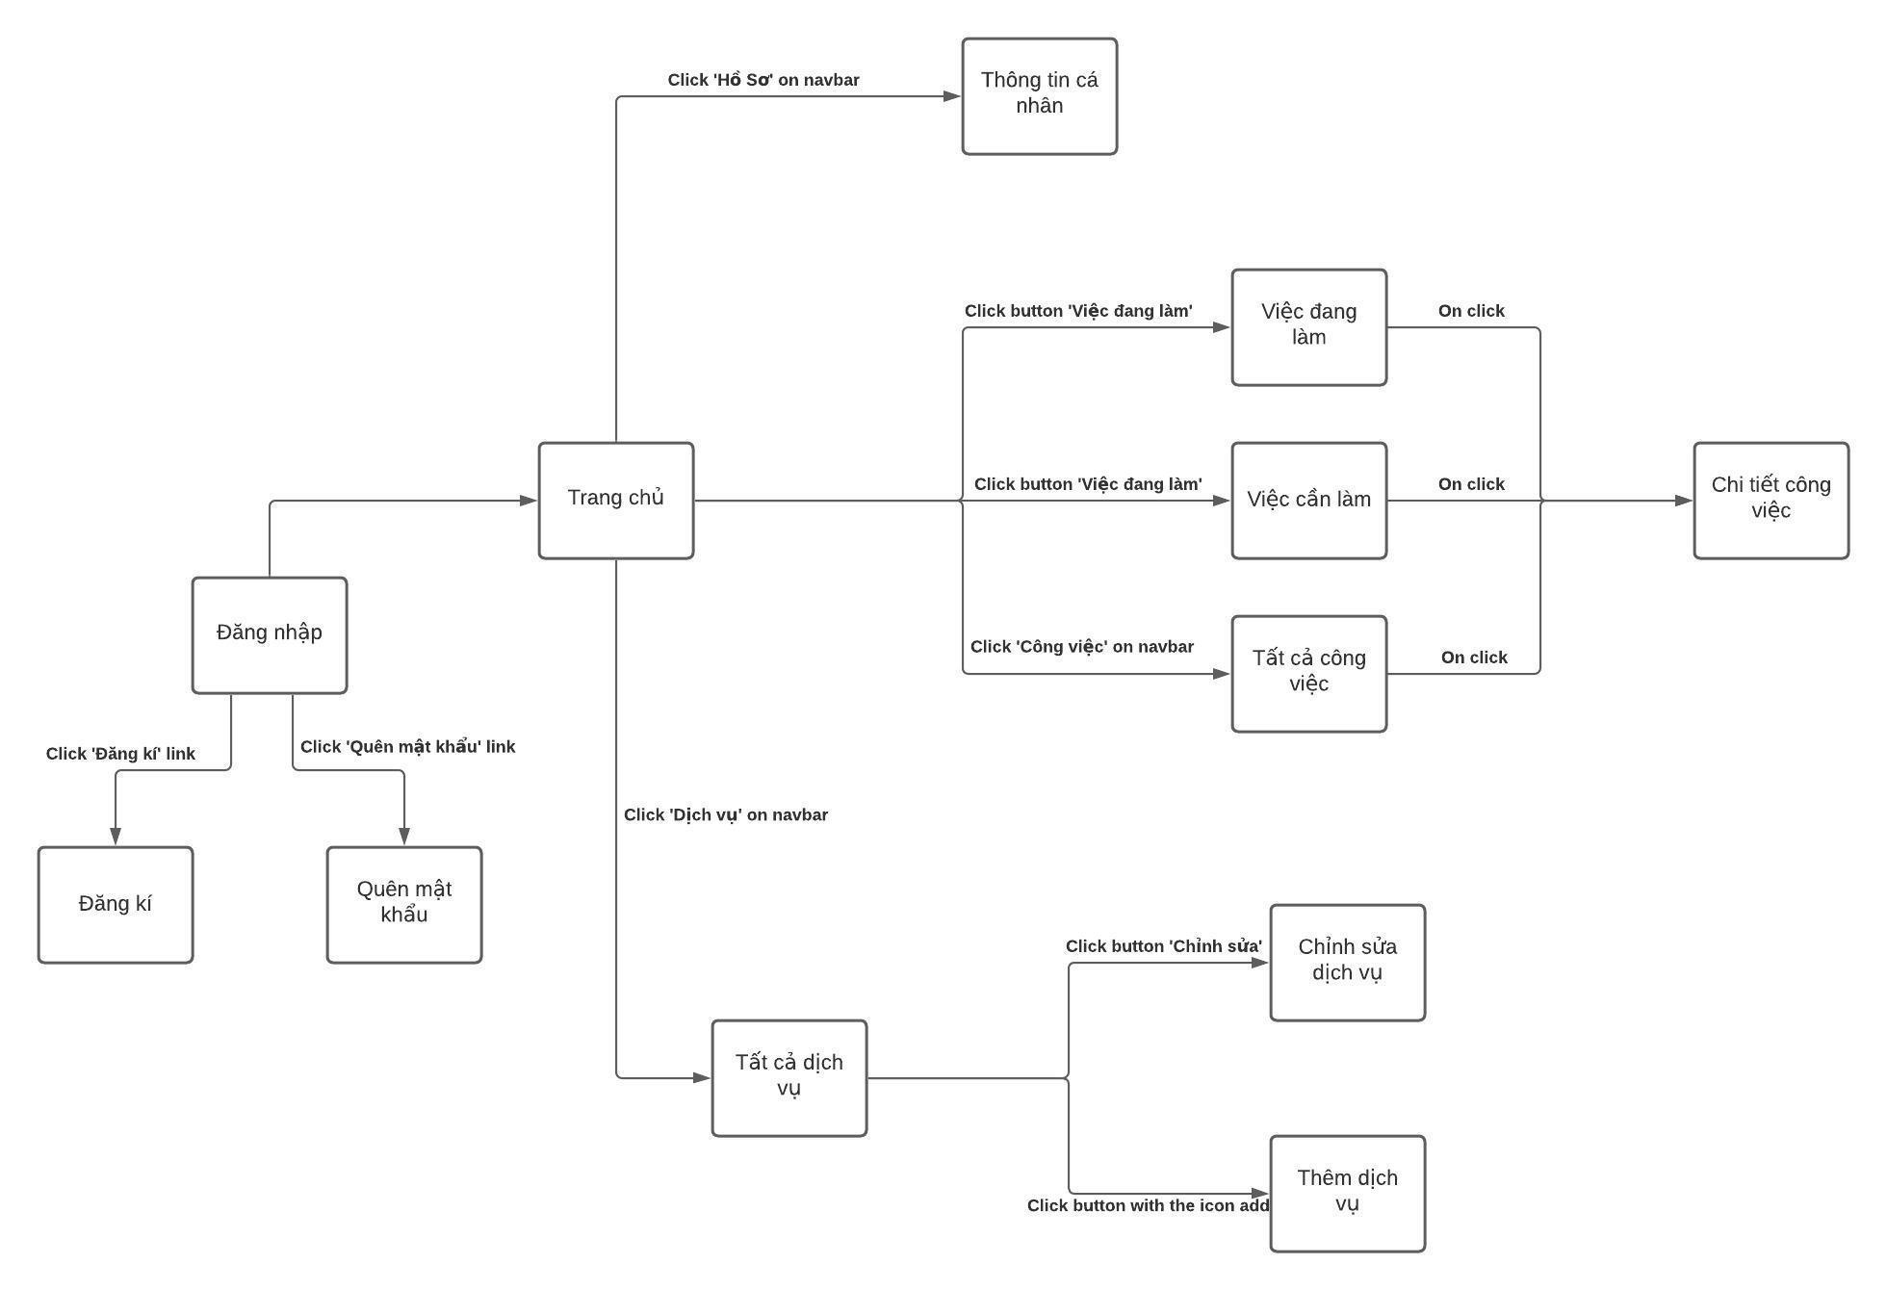

#### b. Screen Details

1. ***Customer’s screen Details***

|  |  |  |  |
| --- | --- | --- | --- |
| **#** | **Feature** | **Screen** | **Description** |
| 1 | Register | Register | Register screen included: avatar, username, fullname, password, re-password, phone number, address, email. |
| 2 | Login | Login | Login screen included: username, password |
| 3 | Login | Forgot password | Forgot password screen included: Old password, new password, re-password. |
| 4 | View application | Main screen | Main screen included: Search icon, category, photographer is appreciated, Album is appreciated… |
| 5 | View profile | Profile | Profile screen included: fullname, username, phone number, address, email. |
| 6 | Update profile | Edit profile | Edit profile screen included: fullname, phone number, address, email. |
| 7 | View request | Request | Request screen included: Status, name photographer, schedule/time, package service, address. |
| 8 | View request | Request detail | Detail request screen included: Status, name photographer, schedule/time, package service, address. |
| 9 | Update request | Change schedule/time | Change booking time screen included: calendar |
| 10 | Update request | Change delivery schedule/time | Change delivery time screen included: calendar |
| 11 | Update request | Change address | Change booking address screen included: map |
| 12 | View album | Album detail | Detail album screen include: like, photographer, description |
| 13 | View album | Like album | “Like” screen include: number of hearts |
| 14 | View profile photographer | Photographer’s profile | Profile photographer screen included: name, review, description, album, package service, schedule. |
| 15 | Book photographer | Create request | Create request screens include: photographer, schedule/time, delivery schedule, address, package service, price. |
| 16 | Book photographer | Create schedule/time | Create booking time screen included: calendar |
| 17 | Book photographer | Create delivery schedule/time | Create delivery time screen included: calendar |
| 18 | Book photographer | Create address | Create booking address screen included: map |

1. ***Photographer’s screen Details***

|  |  |  |  |
| --- | --- | --- | --- |
| **#** | **Feature** | **Screen** | **Description** |
| 1 | Register | Register | Register screen included: avatar, username, fullname, password, re-password, phone number, address, email. |
| 2 | Login | Login | Login screen included: username, password |
| 3 | Login | Forgot password | Forgot password screen included: Old password, new password, re-password. |
| 4 | View application | Main screen | Main screen included: Search icon, category, photographer is appreciated, Album is appreciated… |
| 5 | View profile | Profile | Profile screen included: fullname, username, phone number, address, email. |
| 6 | Update profile | Edit profile | Edit profile screen included: fullname, phone number, address, email. |
| 7 | View request | Request | Request screen included: Status, name customer, schedule/time, package service, address |
| 8 | View request | Request detail | Detail request screen included: Status, name customer, schedule/time, package service, address. |
| 9 | View request | “Việc đang làm” | “Việc đang làm” screen included: Customer requests are awaiting confirmation. |
| 10 | View request | “Việc cần làm” | “Việc cần làm” screen included: calendar and customer request has been confirmed. |
| 11 | View request | “Tất cả công việc” | “Tất cả công việc” screen included: all status of the customer requests. |
| 12 | Add service | Service | Service screen included: all package service and add service button. |
| 13 | Edit service | Service detail | Service detail included: Name, service, price. |
| 14 | Remove service | Service detail | Service detail included: Name, service, price. |

#### c. Screen Authorization

|  |  |  |  |  |  |
| --- | --- | --- | --- | --- | --- |
| **Screen** | **Guest** | **Customer** | **Photographer** | **Admin** | **Authenticated User** |
| Register | X |  |  |  |  |
| Photographer’s login |  |  | X |  | X |
| Customer’s login |  | X |  |  |  |
| Forgot password |  | X | X | X |  |
| Photographer’s home screen |  |  | X |  |  |
| Customer’s home screen |  | X |  |  |  |
| Search photographer |  | X |  |  |  |
| Category |  |  |  | X |  |
| Photographer is appreciated |  | X |  |  |  |
| Album is appreciated |  | X |  |  |  |
| Photographer’s detail |  | X |  | X |  |
| Package service |  | X |  |  |  |
| Book photographer |  | X |  |  |  |
| Calendar |  | X |  |  |  |
| View review |  | X | X | X |  |
| Booking detail |  | X |  |  |  |
| Choose start time |  | X |  |  |  |
| Choose delivery time |  | X |  |  |  |
| Choose Address |  | X |  |  |  |
| Activity screen |  | X |  |  |  |
| Pending |  |  | X |  |  |
| Upcoming |  |  | X |  |  |
| Post production |  |  | X |  |  |
| Done |  |  | X |  |  |
| Review |  | X |  |  |  |
| Cancel |  | X | X |  |  |
| Setting screen |  | X | X |  |  |
| Profile |  | X | X |  |  |
| Edit profile |  | X | X |  |  |
| Change password |  | X | X |  |  |
| Log out |  |  |  |  | X |
| Service |  |  | X |  |  |
| Service detail |  |  | X |  |  |
| Edit service |  |  | X |  |  |
| Remove Service |  |  | X |  |  |
| Add service |  |  | X |  |  |
| Album |  | X | X |  |  |
| Add album |  |  | X |  |  |
| Edit album |  |  | X |  |  |
| Remove album |  |  | X |  |  |
| Forum |  | X | X | X |  |
| Open thread |  | X | X | X |  |
| Edit thread |  | X | X | X |  |
| Comment thread |  | X | X | X |  |
| Follow thread |  | X | X | X |  |
| Notification |  | X | X |  |  |

In which:

* Guest: A person who cannot use the system’s services and functionalities.
* Customer: A person who can make a request to a photographer.
* Photographer: A person who can update a booking request’s status.
* Admin: A person who manages the whole system.
* Authenticated user: A person who has logged in to the system successfully and can update their profile.

#### d. Non-Screen Functions

*[Provide the descriptions for the non-screen system functions, i.e batch/cron job, service, API, etc.]*

|  |  |  |  |
| --- | --- | --- | --- |
| **#** | **Feature** | **System Function** | **Description** |
| 1 | <<Feature Name>> | <<Function Name1>> | <<Function Name1 Description>> |
| 2 | … |  |  |

#### e. Entity Relationship Diagram

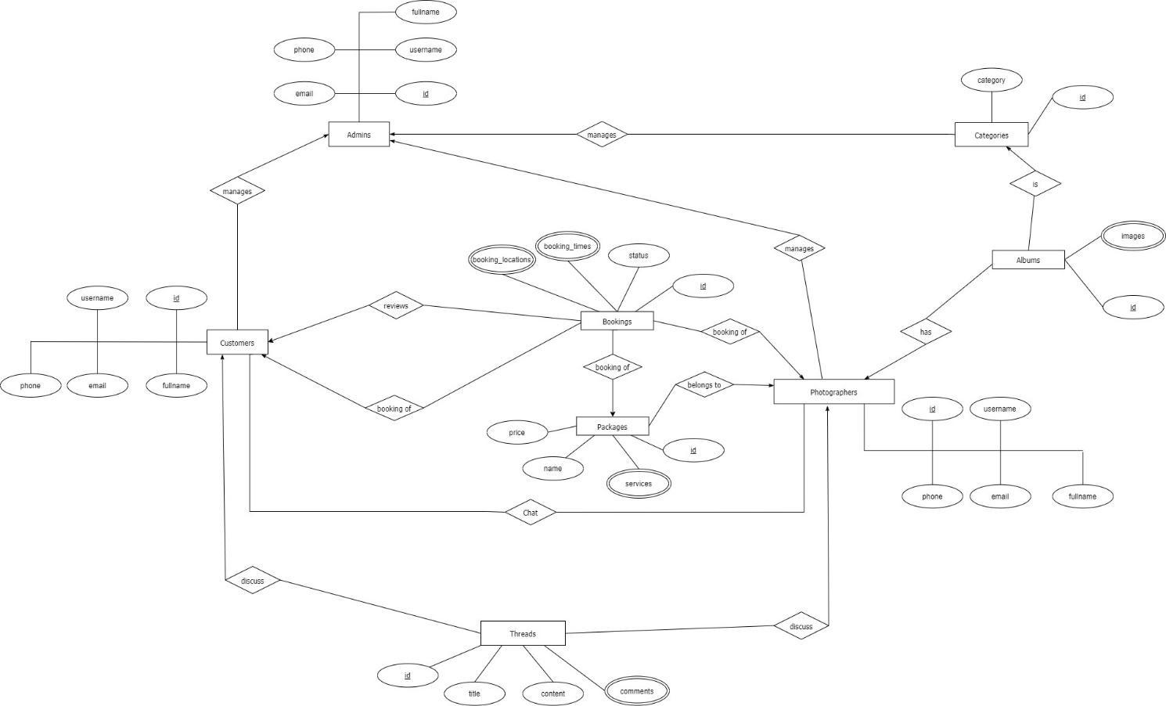

**Entities List**

|  |  |  |
| --- | --- | --- |
| **#** | **Entity** | **Description** |
| 1 | Customer | Customer is an entity representing the person who purchases bookings from photographers: id, username, fullname, phone, email. |
| 2 | Admins | Admin is an entity represents the person who works for pbs system and manages activities of the system: id, username, fullname, phone, email |
| 3 | Booking | Booking is an entity represents the photography deal between photographer and customer: id, status, booking_times, booking_locations |
| 4 | Photographer | Photographer is an entity that represents the person who provides the photography services and takes customers’ deals. |
| 5 | Category | Category is an entity represents the type of albums (is it wedding or look book or anything else): id, category |
| 6 | Album | Album is an entity represents the images which photographer wants to show the customers to attract them: id, images |
| 7 | Package | Package is an entity represents the photography services which photographer provided: id, name, price, services |
| 8 | Thread | Thread is an entity represents a post of photographer or customer or admin on forum: id, title, content, comments |

## 4. Non-Functional Requirements

### 4.1 External Interfaces

#### a. User Interfaces

For web application:

UI-1: GUI has to be simple and easy to use.

UI-2: The language used in the web application is Vietnamese.

UI-3: The web application has to be responsive on multiple devices: laptop, tablet and mobile.

For mobile application:

UI-1: User interface is pleasant to look at and easy to use.

UI-2: The language is Vietnamese.

UI-3: The user interface can be responsive on multiple screen sizes.

UI-4: The functionalities are arranged clearly.

#### b. Software Interfaces

This system will have required software MySQL to program and create and manage the database for the system. Use for source control is Git and GitHub. Test browsers use Chrome 96 or above. Specification for developing the web application is Java EE 11.0.8. Program tools are Visual Studio Code, Android Studio, IntelliJ.

The system will require software window 8 and window 10 to program and manage photographer booking systems. Booking process of the system that organizes the distribution of users in the mobile app and able to do this manage review.

#### c. Hardware Interfaces

Just like any other system, this system requires a basic computer that consists of CPU, monitor, keyboard and mouse or laptop and smartphone for input and output. Smartphones could be used to do booking and use the system. Besides, for direction the system connected with a GPS device in every smartphone to get the location detail.

#### d. Communications Interfaces

The system communication interface is completely dependent on correctly sending and retrieving data from the database. Other than that is an online protocol to connect between GPS and the mobile.

### 4.2 Quality Attributes

#### a. Usability

* The system does not require its users to have any technical knowledge before using its functionalities.
* Layout and navigation are clear and easy to use.
* Customers can use PSB easily even if they have never used it before. They can find a photographer and make a request within 5 minutes.
* Photographers can use PSB easily even if they have never used it before. They can view and confirm requests received from the customers within 5 minutes. They can also use other functionalities quickly and effectively with easy-to-understand instructions and simple operation.

#### b. Reliability

* The availability of the system is 80%. The system can be used within 60 minutes and will automatically log the user out if there is no operation within 5 minutes.

#### c. Performance

All requests will be processed within 10 seconds on an Internet connection above 25Mbps.

#### d. Dependability

##### d1. Security

* All user’s passwords will be encrypted before being saved into the database.
* Accounts will be verified by email.
* Username must be unique.
* Photographers’ email and phone number will be secured.

##### d2. Safety

* A service price a photographer has posted cannot be changed when a customer chooses that service. If there is a surcharge, it must be negotiated with the customer.
* When the photos return day has come, if the photographer does not return the photos, the request will be cancelled automatically.

#### e. Supportability

* Online bookings in real time: The customer will be able to see all the available dates directly, and make a booking. If there is no further availability on one date, this will be blocked in real time to prevent further bookings.
* Intelligent calendar: An intelligent and easy-to-understand booking or occupancy calendar provides the user with a summary of all bookings, capacity and turnover for the required periods at a glance.
* Online and chat support for booking systems.
* Booking management via smartphone.

#### f. Design Constraints

* The software language is Vietnamese.
* The software process is Scrum.

#### g. Support Documents

The system does not use any references to support document writing.

#### h. Purchased Components

To support the system operation, we have used some third-party services such as:

* Google Map API
* AWS S3

## 5. Other Requirements

### Messages List

|  |  |  |  |  |
| --- | --- | --- | --- | --- |
| # | Message code | Message Type | Context | Content |
| 1 | MSG01 | In line | There is not any search result | Không có kết quả. |
| 2 | MSG02 | In red, under the text box | Input-required fields are empty | Thông tin này là bắt buộc. |
| 3 | MSG03 | Toast message | Updating asset(s) information successfully | Cập nhật thành công. |
| 4 | MSG04 | Toast message | Adding new asset successfully | Thêm * thành công. |
| 5 | MSG05 | Toast message | Confirming email of asset hand-over is sent successfully | A confirmation email has been sent to {email_address}. |
| 6 | MSG06 | Toast message | Resetting asset information successfully | Thay đổi * thành công |
| 7 | MSG07 | Toast message | Deleting asset information successfully | Xóa * thành công. |
| 8 | MSG08 | In red, under the text box | Input value length > max length | Bạn vui lòng nhập đủ{max_length} ký tự. |
| 9 | MSG09 | In line | Username or password is not correct when clicking sign-in | Thông tin đăng nhập không chính xác. |
| 10 | MSG10 | In line | Password and Confirm password are not matched. | Mật khẩu nhập lại không khớp. |
| 11 | MSG11 | Toast message | Register successfully | Đăng ký thành công |
| 12 | MSG12 | In red, under the text box | Email is invalid | Email mail này không hợp lệ. Vui lòng nhập email khác |
| 13 | MSG13 | In red, under the text box | Username is existing | Tên đăng nhập của bạn đã có người sử dụng. Vui lòng nhập tên khác |
| 14 | MSG14 | Toast message | The customer book photographer successfully. | Gửi yêu cầu thành công. |
| 15 | MSG15 | In red, under the text box | The customer does not choose a calendar and address. | Bạn chưa chọn thông tin. |
| 16 | MSG16 | Notifications | The system sends notifications to the customer when photographers accept requests. | Yêu cầu của bạn đã được xác nhận |
| 17 | MSG17 | Notifications | The system sends notification to the customer when a photographer declines a request. | Yêu cầu của bạn đã bị từ chối. |
| 18 | MSG18 | In red, under the text box | Current password is invalid | Mật khẩu nhập lại chưa chính xác |
| 19 | MSG19 | Toast message | The system shows notifications to the admin when blocking users. | Bạn có muốn khóa người dùng này? |
| 20 | MSG20 | Toast message | The admin block user successfully. | Người dùng đã được khóa thành công. |
| 21 | MSG21 | Toast message | The system sends notifications to the user when the account has been blocked. | Tài khoản của bạn đã bị vi phạm. Vui lòng liên hệ với quản trị viên |
| 22 | MSG22 | Toast message | The system shows notifications to the admin when unblocking the user. | Bạn có muốn mở khóa người dùng này? |
| 23 | MSG23 | Toast message | The system sends notifications to the user when the account has unblocked. | Người dùng đã được mở khóa thành công |
| 24 | MSG24 | In red, under the text box | Information is duplicated | * đã tồn tại. |

***Table 1 - Message list***